**Exercise 16: Registration Form with Validation**

**Task:** Create a registration form with multiple fields (name, email, password) and use JavaScript to validate the form. Ensure that all fields are filled and the email is valid.

**HTML:**

<!DOCTYPE html>

<html lang="en">

<head>

<meta charset="UTF-8">

<meta name="viewport" content="width=device-width, initial-scale=1.0">

<title>Registration Form</title>

<link rel="stylesheet" href="styles.css">

</head>

<body>

<form id="registrationForm">

<label for="regName">Name:</label>

<input type="text" id="regName" name="name"><br>

<label for="regEmail">Email:</label>

<input type="email" id="regEmail" name="email"><br>

<label for="regPassword">Password:</label>

<input type="password" id="regPassword" name="password"><br>

<button type="button" onclick="validateRegistration()">Register</button>

</form>

<div id="registrationOutput"></div>

<script src="script.js"></script>

</body>

</html>

**CSS (styles.css):**

body {

font-family: Arial, sans-serif;

padding: 20px;

}

form {

max-width: 500px;

margin: auto;

border: 1px solid #ddd;

padding: 20px;

border-radius: 8px;

background-color: #f9f9f9;

}

label {

display: block;

margin: 10px 0 5px;

}

input {

width: calc(100% - 22px);

padding: 8px;

border: 1px solid #ccc;

border-radius: 4px;

}

button {

padding: 10px 20px;

background-color: #4CAF50;

color: white;

border: none;

border-radius: 4px;

cursor: pointer;

}

button:hover {

background-color: #45a049;

}

#registrationOutput {

margin-top: 20px;

}

**JavaScript (script.js):**

function validateRegistration() {

const name = document.getElementById('regName').value;

const email = document.getElementById('regEmail').value;

const password = document.getElementById('regPassword').value;

let message = '';

if (!name) {

message += 'Name is required.<br>';

}

if (!email || !validateEmail(email)) {

message += 'A valid email is required.<br>';

}

if (!password) {

message += 'Password is required.<br>';

}

if (message === '') {

message = 'Registration successful!';

}

document.getElementById('registrationOutput').innerHTML = message;

}

function validateEmail(email) {

const re = /^[^\s@]+@[^\s@]+\.[^\s@]+$/;

return re.test(email);

}

**Exercise 17: User Registration Form**

**Question:** Create a user registration form that includes the following fields:

1. Full Name (required)
2. Email (required, valid email format)
3. Password (required, at least 8 characters)
4. Confirm Password (required, must match the Password field)
5. Phone Number (required, 10 digits)
6. Date of Birth (required)
7. Gender (required, with options: Male, Female, Other)
8. Terms and Conditions (required to be checked)

**Requirements:**

1. Style the form with CSS to make it look clean and modern.
2. Implement JavaScript validation to ensure:
   * Full Name is not empty.
   * Email is in a valid format.
   * Password is at least 8 characters long.
   * Confirm Password matches Password.
   * Phone Number is exactly 10 digits.
   * Date of Birth is selected.
   * Gender is selected.
   * Terms and Conditions checkbox is checked.
3. Display appropriate error messages for invalid inputs.

**HTML:**

<!DOCTYPE html>

<html lang="en">

<head>

<meta charset="UTF-8">

<meta name="viewport" content="width=device-width, initial-scale=1.0">

<title>User Registration Form</title>

<link rel="stylesheet" href="styles.css">

</head>

<body>

<form id="registrationForm">

<h2>User Registration</h2>

<label for="fullName">Full Name:</label>

<input type="text" id="fullName" name="fullName" required>

<span class="error" id="fullNameError"></span>

<label for="email">Email:</label>

<input type="email" id="email" name="email" required>

<span class="error" id="emailError"></span>

<label for="password">Password:</label>

<input type="password" id="password" name="password" required minlength="8">

<span class="error" id="passwordError"></span>

<label for="confirmPassword">Confirm Password:</label>

<input type="password" id="confirmPassword" name="confirmPassword" required minlength="8">

<span class="error" id="confirmPasswordError"></span>

<label for="phone">Phone Number:</label>

<input type="tel" id="phone" name="phone" pattern="[0-9]{10}" required>

<span class="error" id="phoneError"></span>

<label for="dob">Date of Birth:</label>

<input type="date" id="dob" name="dob" required>

<span class="error" id="dobError"></span>

<label for="gender">Gender:</label>

<select id="gender" name="gender" required>

<option value="" disabled selected>Select your gender</option>

<option value="male">Male</option>

<option value="female">Female</option>

<option value="other">Other</option>

</select>

<span class="error" id="genderError"></span>

<label for="terms">

<input type="checkbox" id="terms" name="terms" required>

I agree to the terms and conditions

</label>

<span class="error" id="termsError"></span>

<button type="button" onclick="validateForm()">Register</button>

</form>

<div id="formOutput"></div>

<script src="script.js"></script>

</body>

</html>

**CSS (styles.css):**

body {

font-family: Arial, sans-serif;

padding: 20px;

background-color: #f4f4f4;

}

form {

max-width: 600px;

margin: auto;

padding: 20px;

border: 1px solid #ddd;

border-radius: 8px;

background-color: #fff;

}

h2 {

text-align: center;

color: #333;

}

label {

display: block;

margin: 10px 0 5px;

}

input, select {

width: calc(100% - 22px);

padding: 10px;

border: 1px solid #ccc;

border-radius: 4px;

margin-bottom: 10px;

}

input[type="checkbox"] {

margin-right: 10px;

}

button {

display: block;

width: 100%;

padding: 10px;

background-color: #4CAF50;

color: white;

border: none;

border-radius: 4px;

cursor: pointer;

}

button:hover {

background-color: #45a049;

}

.error {

color: #d9534f;

font-size: 0.875em;

}

#formOutput {

margin-top: 20px;

text-align: center;

}

**JavaScript (script.js):**

function validateForm() {

let valid = true;

// Clear previous errors

document.querySelectorAll('.error').forEach(e => e.textContent = '');

// Validate Full Name

const fullName = document.getElementById('fullName').value;

if (!fullName) {

document.getElementById('fullNameError').textContent = 'Full Name is required.';

valid = false;

}

// Validate Email

const email = document.getElementById('email').value;

if (!email || !validateEmail(email)) {

document.getElementById('emailError').textContent = 'A valid Email is required.';

valid = false;

}

// Validate Password

const password = document.getElementById('password').value;

if (!password || password.length < 8) {

document.getElementById('passwordError').textContent = 'Password must be at least 8 characters long.';

valid = false;

}

// Validate Confirm Password

const confirmPassword = document.getElementById('confirmPassword').value;

if (confirmPassword !== password) {

document.getElementById('confirmPasswordError').textContent = 'Passwords do not match.';

valid = false;

}

// Validate Phone Number

const phone = document.getElementById('phone').value;

if (!phone || !/^\d{10}$/.test(phone)) {

document.getElementById('phoneError').textContent = 'Phone Number must be 10 digits.';

valid = false;

}

// Validate Date of Birth

const dob = document.getElementById('dob').value;

if (!dob) {

document.getElementById('dobError').textContent = 'Date of Birth is required.';

valid = false;

}

// Validate Gender

const gender = document.getElementById('gender').value;

if (!gender) {

document.getElementById('genderError').textContent = 'Gender is required.';

valid = false;

}

// Validate Terms and Conditions

const terms = document.getElementById('terms').checked;

if (!terms) {

document.getElementById('termsError').textContent = 'You must agree to the terms and conditions.';

valid = false;

}

if (valid) {

document.getElementById('formOutput').innerHTML = '<h3>Registration Successful!</h3>';

}

}

function validateEmail(email) {

const re = /^[^\s@]+@[^\s@]+\.[^\s@]+$/;

return re.test(email);

}

**Exercise 18: Job Application Form**

**Question:** Design a job application form with the following fields:

1. Name (required)
2. Email (required, valid email format)
3. Phone Number (required, 10 digits)
4. Resume (required, must be a PDF file)
5. Cover Letter (required)
6. Experience (required, non-negative number)
7. Availability (required, options: Immediate, In 2 Weeks, In 1 Month)

**Requirements:**

1. Apply CSS to make the form visually appealing.
2. Implement JavaScript validation to ensure:
   * Name is not empty.
   * Email is in a valid format.
   * Phone Number is exactly 10 digits.
   * Resume is provided and is a PDF file.
   * Cover Letter is not empty.
   * Experience is a non-negative number.
   * Availability is selected.
3. Provide error messages for each field as needed.

**HTML:**

<!DOCTYPE html>

<html lang="en">

<head>

<meta charset="UTF-8">

<meta name="viewport" content="width=device-width, initial-scale=1.0">

<title>Job Application Form</title>

<link rel="stylesheet" href="styles.css">

</head>

<body>

<form id="jobApplicationForm">

<h2>Job Application</h2>

<label for="name">Name:</label>

<input type="text" id="name" name="name" required>

<span class="error" id="nameError"></span>

<label for="email">Email:</label>

<input type="email" id="email" name="email" required>

<span class="error" id="emailError"></span>

<label for="phone">Phone Number:</label>

<input type="tel" id="phone" name="phone" pattern="[0-9]{10}" required>

<span class="error" id="phoneError"></span>

<label for="resume">Resume (PDF only):</label>

<input type="file" id="resume" name="resume" accept=".pdf" required>

<span class="error" id="resumeError"></span>

<label for="coverLetter">Cover Letter:</label>

<textarea id="coverLetter" name="coverLetter" rows="5" required></textarea>

<span class="error" id="coverLetterError"></span>

<label for="experience">Experience (Years):</label>

<input type="number" id="experience" name="experience" min="0" required>

<span class="error" id="experienceError"></span>

<label for="availability">Availability:</label>

<select id="availability" name="availability" required>

<option value="" disabled selected>Select availability</option>

<option value="immediate">Immediate</option>

<option value="2-weeks">In 2 Weeks</option>

<option value="1-month">In 1 Month</option>

</select>

<span class="error" id="availabilityError"></span>

<button type="button" onclick="validateApplication()">Submit Application</button>

</form>

<div id="applicationOutput"></div>

<script src="script.js"></script>

</body>

</html>

**CSS (styles.css):**

body {

font-family: Arial, sans-serif;

padding: 20px;

background-color: #e9ecef;

}

form {

max-width: 700px;

margin: auto;

padding: 20px;

border: 1px solid #ddd;

border-radius: 8px;

background-color: #ffffff;

}

h2 {

text-align: center;

color: #333;

}

label {

display: block;

margin: 10px 0 5px;

}

input, textarea, select {

width: calc(100% - 22px);

padding: 10px;

border: 1px solid #ccc;

border-radius: 4px;

margin-bottom: 10px;

}

input[type="file"] {

border: none;

padding: 0;

}

button {

display: block;

width: 100%;

padding: 10px;

background-color: #007bff;

color: white;

border: none;

border-radius: 4px;

cursor: pointer;

}

button:hover {

background-color: #0056b3;

}

.error {

color: #dc3545;

font-size: 0.875em;

}

#applicationOutput {

margin-top: 20px;

text-align: center;

}

**JavaScript (script.js):**

function validateApplication() {

let valid = true;

// Clear previous errors

document.querySelectorAll('.error').forEach(e => e.textContent = '');

// Validate Name

const name = document.getElementById('name').value;

if (!name) {

document.getElementById('nameError').textContent = 'Name is required.';

valid = false;

}

// Validate Email

const email = document.getElementById('email').value;

if (!email || !validateEmail(email)) {

document.getElementById('emailError').textContent = 'A valid Email is required.';

valid = false;

}

// Validate Phone Number

const phone = document.getElementById('phone').value;

if (!phone || !/^\d{10}$/.test(phone)) {

document.getElementById('phoneError').textContent = 'Phone Number must be 10 digits.';

valid = false;

}

// Validate Resume

const resume = document.getElementById('resume').files[0];

if (!resume || resume.type !== 'application/pdf') {

document.getElementById('resumeError').textContent = 'Resume must be a PDF file.';

valid = false;

}

// Validate Cover Letter

const coverLetter = document.getElementById('coverLetter').value;

if (!coverLetter) {

document.getElementById('coverLetterError').textContent = 'Cover Letter is required.';

valid = false;

}

// Validate Experience

const experience = document.getElementById('experience').value;

if (experience === '' || experience < 0) {

document.getElementById('experienceError').textContent = 'Experience must be a non-negative number.';

valid = false;

}

// Validate Availability

const availability = document.getElementById('availability').value;

if (!availability) {

document.getElementById('availabilityError').textContent = 'Availability is required.';

valid = false;

}

if (valid) {

document.getElementById('applicationOutput').innerHTML = '<h3>Application Submitted Successfully!</h3>';

}

}

function validateEmail(email) {

const re = /^[^\s@]+@[^\s@]+\.[^\s@]+$/;

return re.test(email);

}

**Exercise 19: Event Registration Form**

**Question:** Develop an event registration form with the following fields:

1. First Name (required)
2. Last Name (required)
3. Email (required, valid email format)
4. Phone Number (required, 10 digits)
5. Event Date (required)
6. Ticket Type (required, options: Standard, VIP)
7. Comments (optional)

**Requirements:**

1. Use CSS to ensure the form looks professional and user-friendly.
2. Write JavaScript validation to:
   * Ensure First Name and Last Name are not empty.
   * Validate that Email is in the correct format.
   * Confirm Phone Number is exactly 10 digits.
   * Ensure Event Date is selected.
   * Verify that a Ticket Type is chosen.
3. Show appropriate error messages for invalid inputs and display a success message upon successful registration.

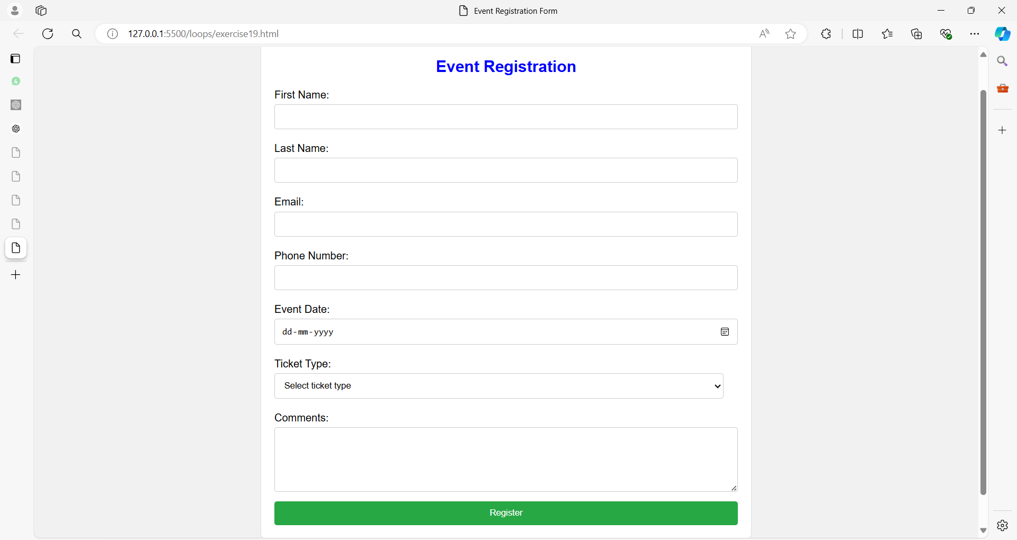

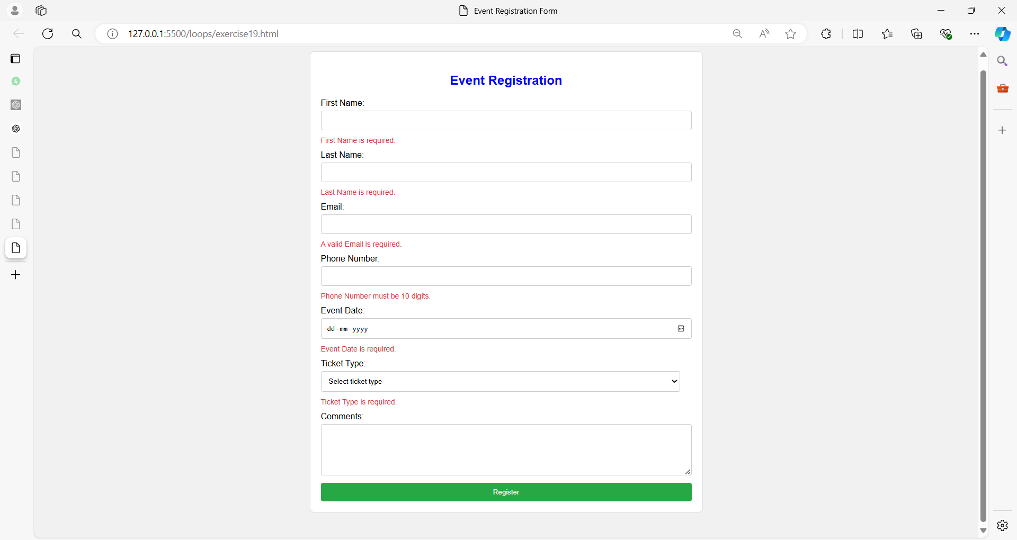

**HTML:**

<!DOCTYPE html>

<html lang="en">

<head>

<meta charset="UTF-8">

<meta name="viewport" content="width=device-width, initial-scale=1.0">

<title>Event Registration Form</title>

<link rel="stylesheet" href="styles.css">

</head>

<body>

<form id="eventRegistrationForm">

<h2>Event Registration</h2>

<label for="firstName">First Name:</label>

<input type="text" id="firstName" name="firstName" required>

<span class="error" id="firstNameError"></span>

<label for="lastName">Last Name:</label>

<input type="text" id="lastName" name="lastName" required>

<span class="error" id="lastNameError"></span>

<label for="email">Email:</label>

<input type="email" id="email" name="email" required>

<span class="error" id="emailError"></span>

<label for="phone">Phone Number:</label>

<input type="tel" id="phone" name="phone" pattern="[0-9]{10}" required>

<span class="error" id="phoneError"></span>

<label for="eventDate">Event Date:</label>

<input type="date" id="eventDate" name="eventDate" required>

<span class="error" id="eventDateError"></span>

<label for="ticketType">Ticket Type:</label>

<select id="ticketType" name="ticketType" required>

<option value="" disabled selected>Select ticket type</option>

<option value="standard">Standard</option>

<option value="vip">VIP</option>

</select>

<span class="error" id="ticketTypeError"></span>

<label for="comments">Comments:</label>

<textarea id="comments" name="comments" rows="5"></textarea>

<button type="button" onclick="validateEventRegistration()">Register</button>

</form>

<div id="eventOutput"></div>

<script src="script.js"></script>

</body>

</html>

**CSS (styles19.css):**

body {

font-family: Arial, sans-serif;

padding: 20px;

background-color: #f1f1f1;

}

form {

max-width: 700px;

margin: auto;

padding: 20px;

border: 1px solid #ddd;

border-radius: 8px;

background-color: #fff;

}

h2 {

text-align: center;

color: blue;

}

label {

display: block;

margin: 10px 0 5px;

}

input, select, textarea {

width: calc(100% - 22px);

padding: 10px;

border: 1px solid #ccc;

border-radius: 4px;

margin-bottom: 10px;

}

button {

display: block;

width: 100%;

padding: 10px;

background-color: #28a745;

color: white;

border: none;

border-radius: 4px;

cursor: pointer;

}

button:hover {

background-color: #218838;

}

.error {

color: #dc3545;

font-size: 0.875em;

}

#eventOutput {

margin-top: 20px;

text-align: center;

}

**JavaScript (script19.js):**

function validateEventRegistration() {

let valid = true;

// Clear previous errors

document.querySelectorAll('.error').forEach(e => e.textContent = '');

// Validate First Name

const firstName = document.getElementById('firstName').value;

if (!firstName) {

document.getElementById('firstNameError').textContent = 'First Name is required.';

valid = false;

}

// Validate Last Name

const lastName = document.getElementById('lastName').value;

if (!lastName) {

document.getElementById('lastNameError').textContent = 'Last Name is required.';

valid = false;

}

// Validate Email

const email = document.getElementById('email').value;

if (!email || !validateEmail(email)) {

document.getElementById('emailError').textContent = 'A valid Email is required.';

valid = false;

}

// Validate Phone Number

const phone = document.getElementById('phone').value;

if (!phone || !/^\d{10}$/.test(phone)) {

document.getElementById('phoneError').textContent = 'Phone Number must be 10 digits.';

valid = false;

}

// Validate Event Date

const eventDate = document.getElementById('eventDate').value;

if (!eventDate) {

document.getElementById('eventDateError').textContent = 'Event Date is required.';

valid = false;

}

// Validate Ticket Type

const ticketType = document.getElementById('ticketType').value;

if (!ticketType) {

document.getElementById('ticketTypeError').textContent = 'Ticket Type is required.';

valid = false;

}

if (valid) {

document.getElementById('eventOutput').innerHTML = '<h3>Registration Successful!</h3>';

}

}

function validateEmail(email) {

const re = /^[^\s@]+@[^\s@]+\.[^\s@]+$/;

return re.test(email);

}

**Exercise 20: Comprehensive User Profile Form**

**Question:** Create a comprehensive user profile form with the following fields:

1. **Personal Information:**
   * Full Name (required)
   * Email (required, valid email format)
   * Phone Number (required, 10 digits)
   * Date of Birth (required)
   * Gender (required, options: Male, Female, Other)
2. **Address Information:**
   * Street Address (required)
   * City (required)
   * State (required)
   * Zip Code (required, 5 digits)
   * Country (required)
3. **Account Settings:**
   * Username (required, alphanumeric)
   * Password (required, at least 8 characters)
   * Confirm Password (required, must match Password)
   * Security Question (required, select from a list)
   * Security Answer (required)
4. **Preferences:**
   * Subscribe to Newsletter (optional)
   * Preferred Contact Method (required, options: Email, Phone, Post)
   * Communication Frequency (required, options: Daily, Weekly, Monthly)
5. **Additional Information:**
   * Bio (optional, textarea)
   * Profile Picture (optional, image file upload)

**Requirements:**

1. Style the form with CSS to create a user-friendly and professional layout.
2. Implement JavaScript validation to:
   * Ensure all required fields are filled out correctly.
   * Validate email, phone number, zip code, and password formats.
   * Check that Confirm Password matches Password.
   * Validate that all dropdowns and options are selected appropriately.
   * Ensure that image file uploads are valid (optional).
3. Provide detailed error messages and a success message upon successful submission.

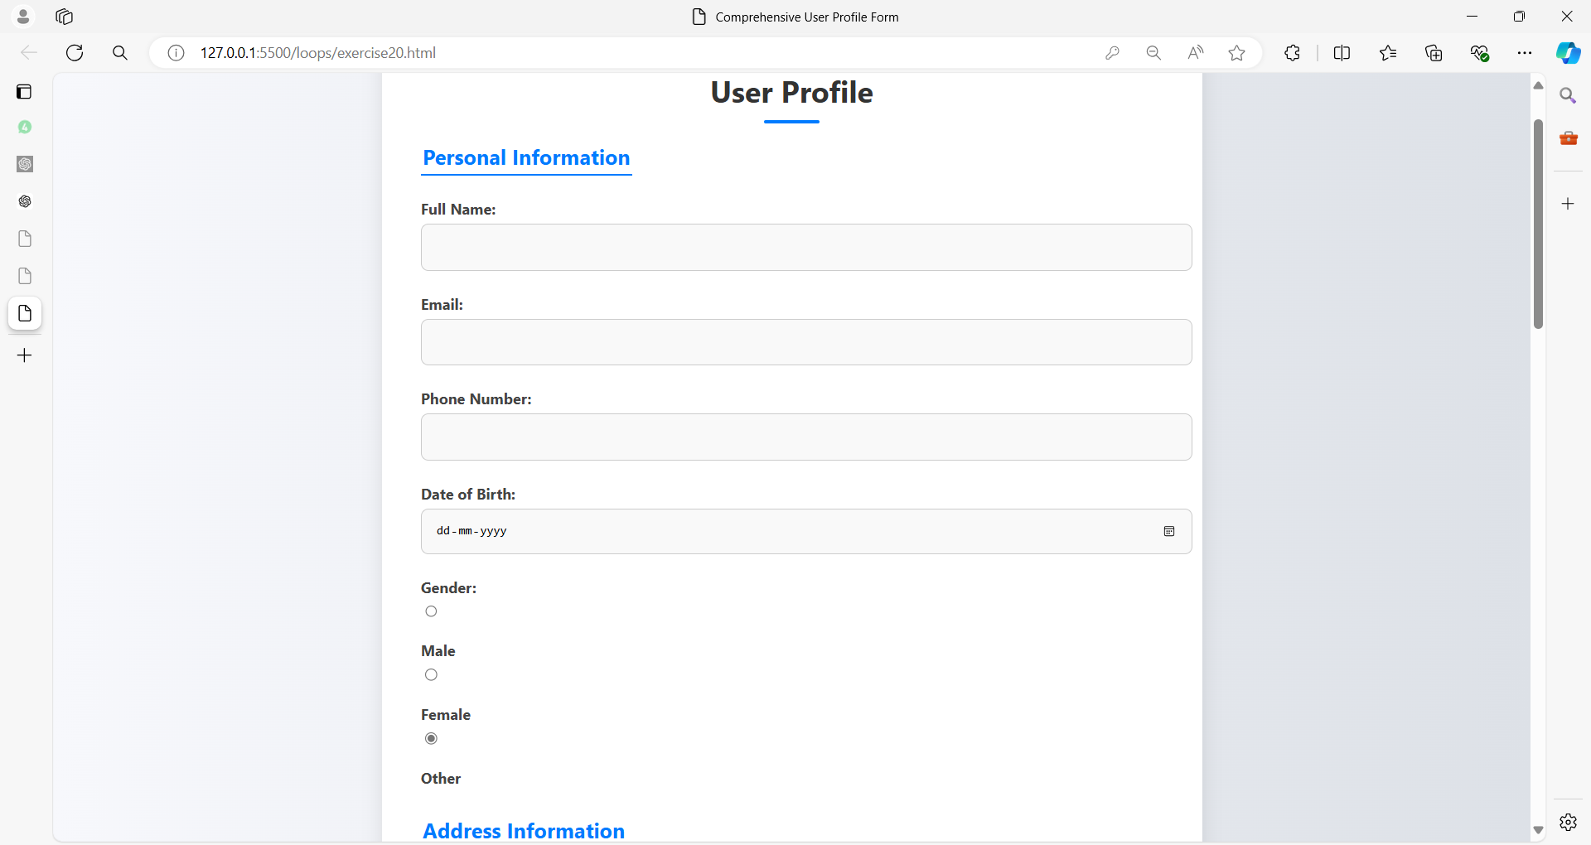

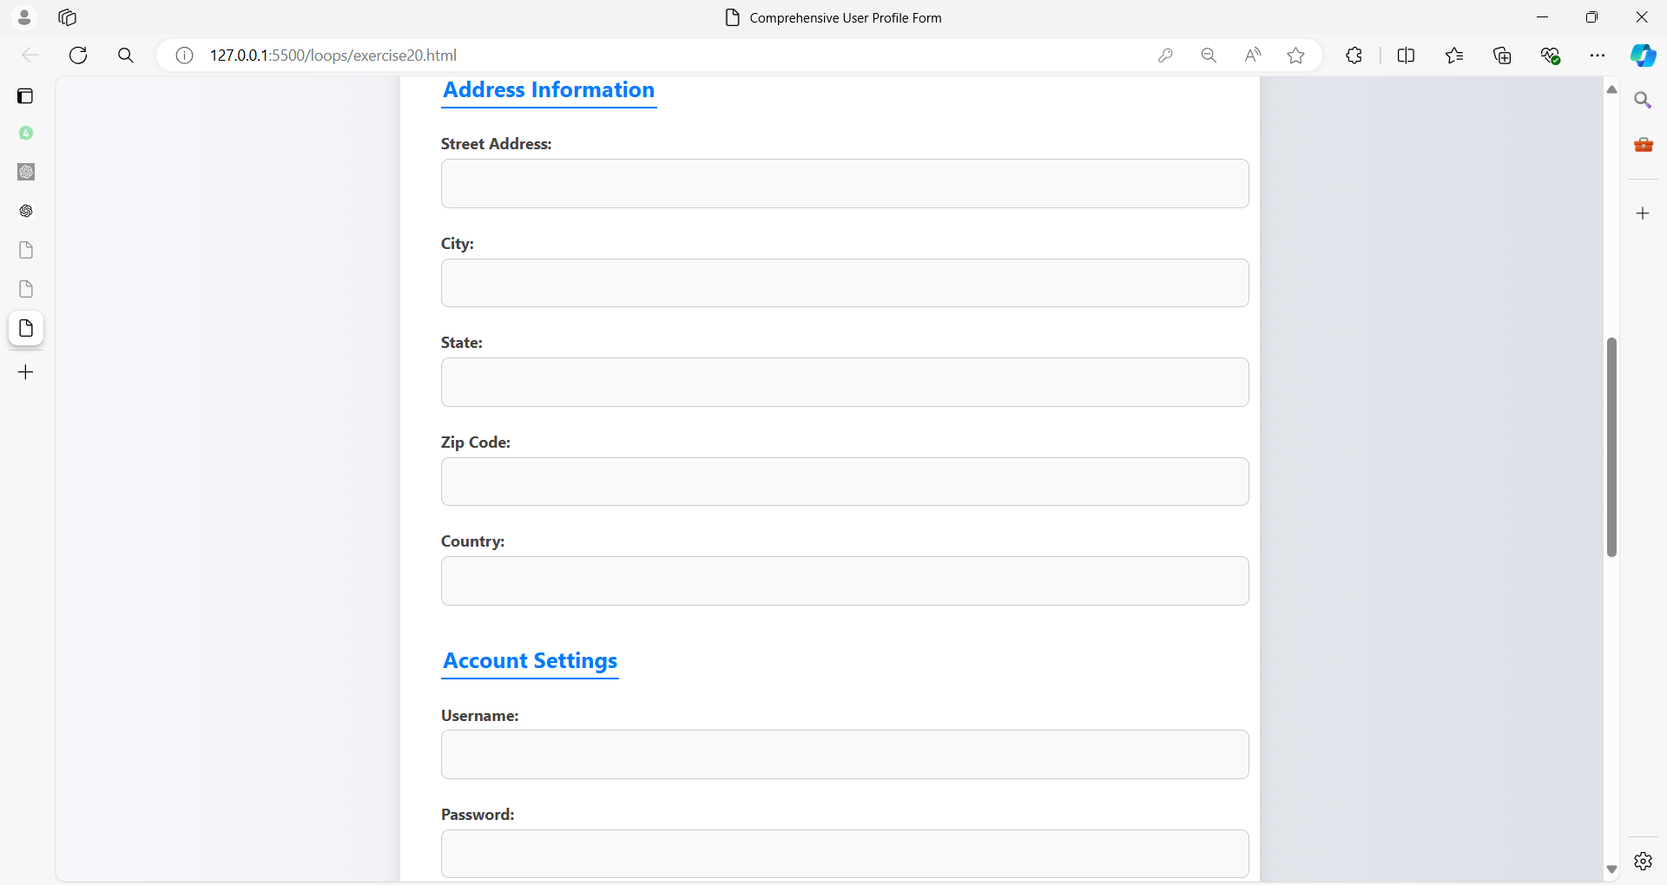

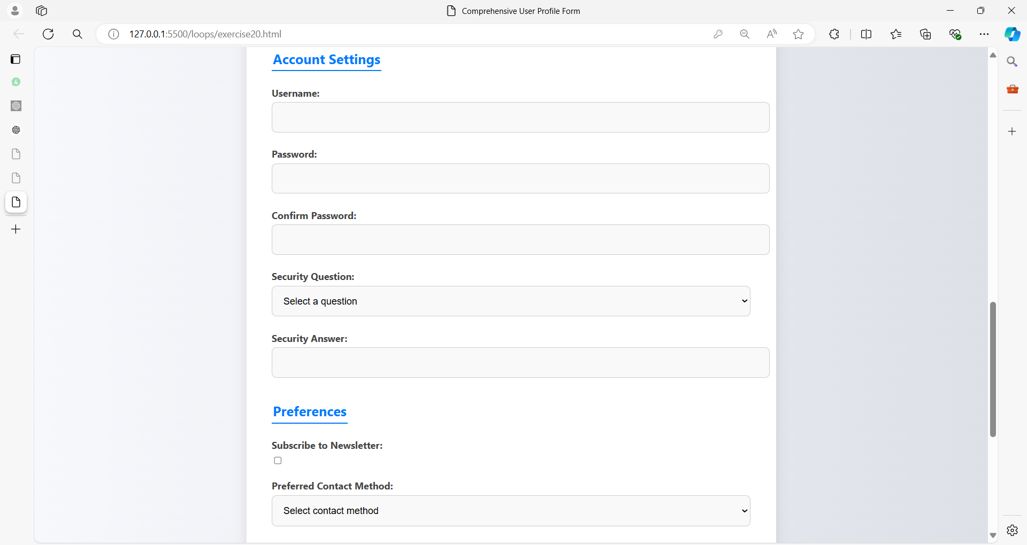

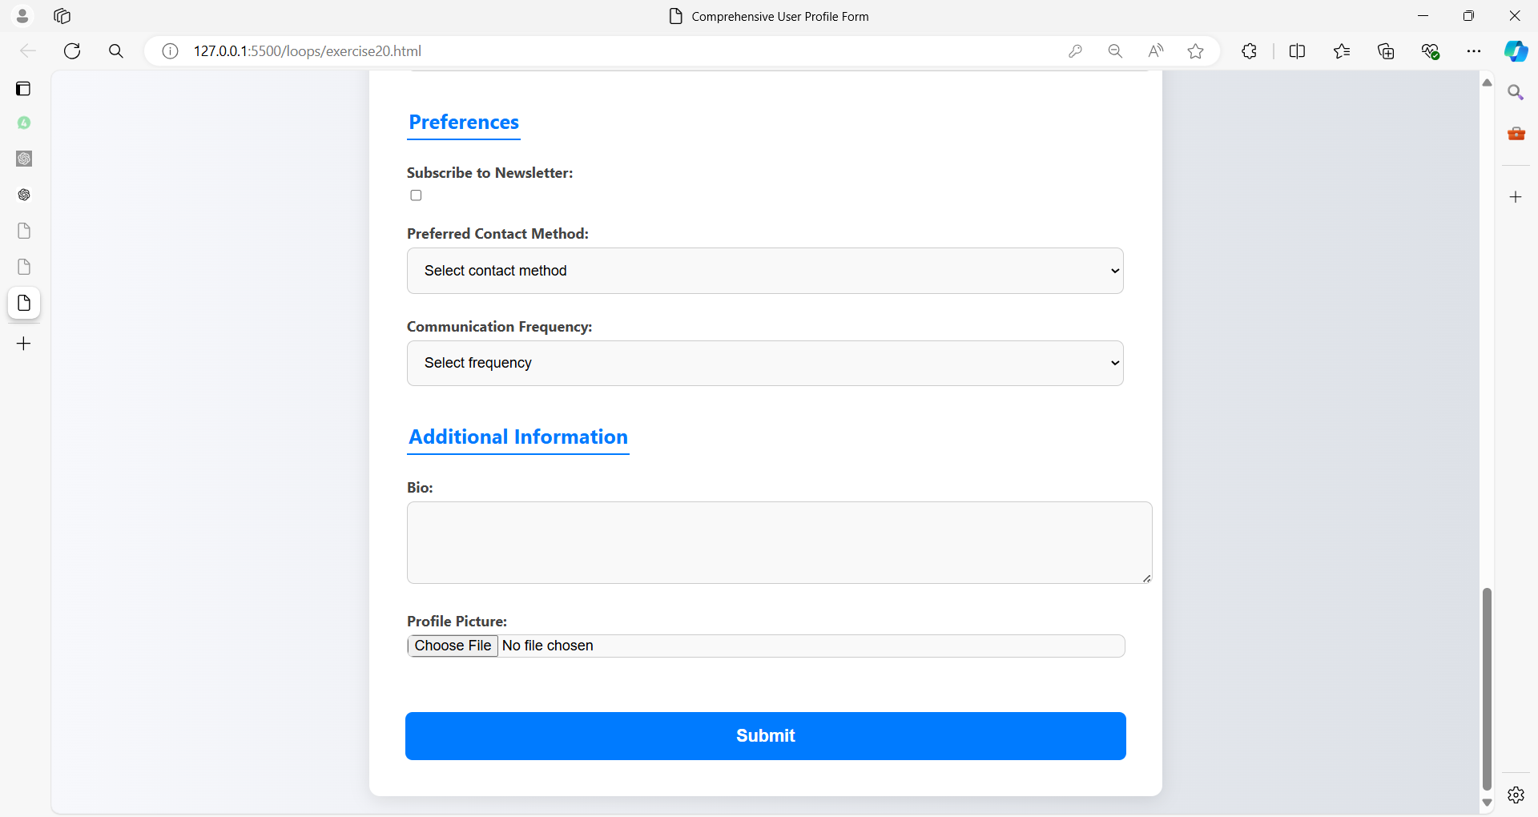

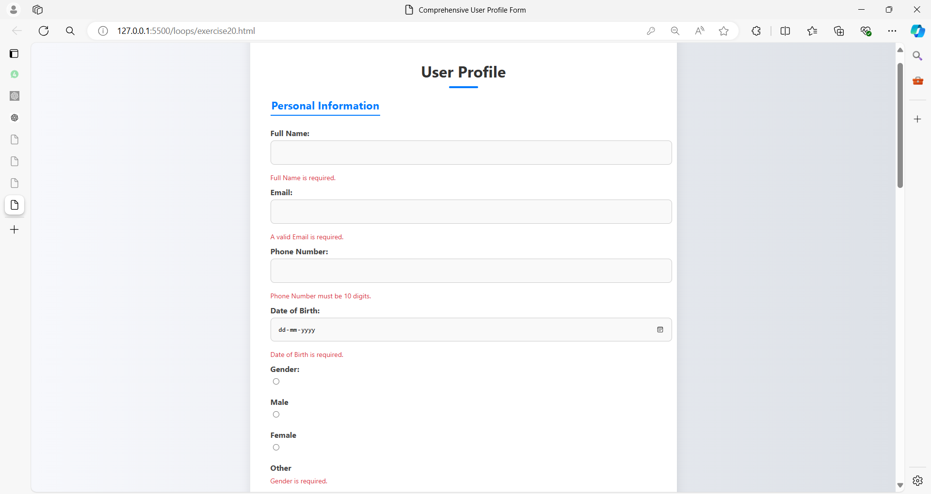

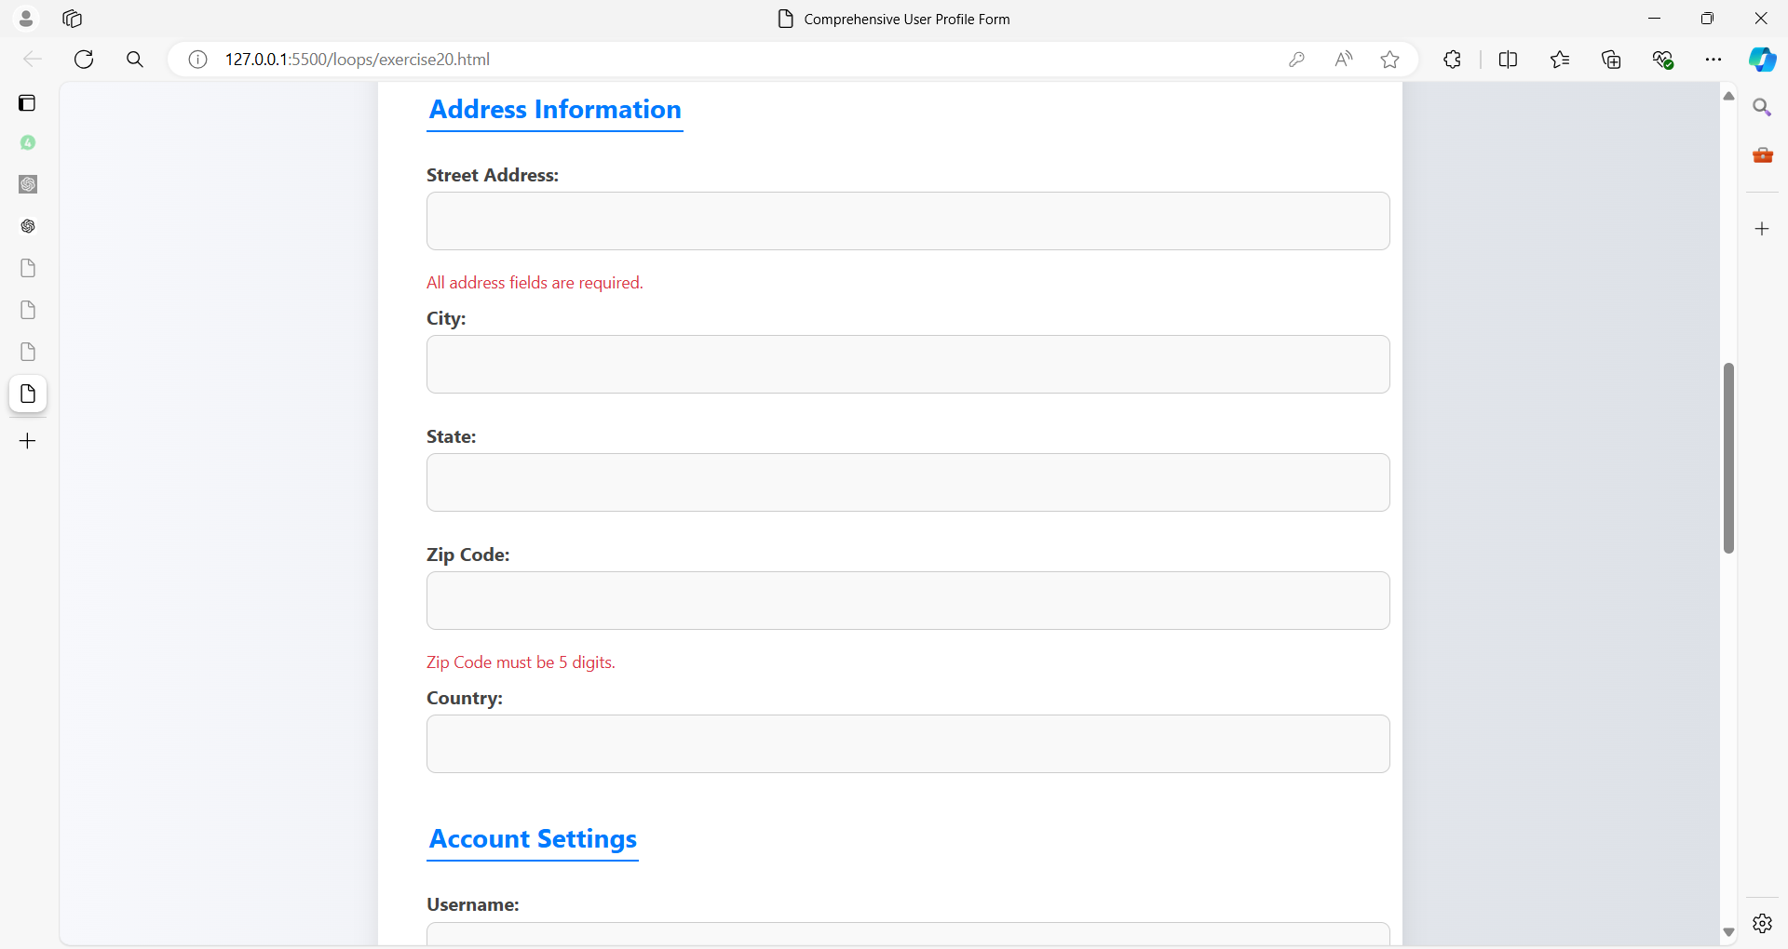

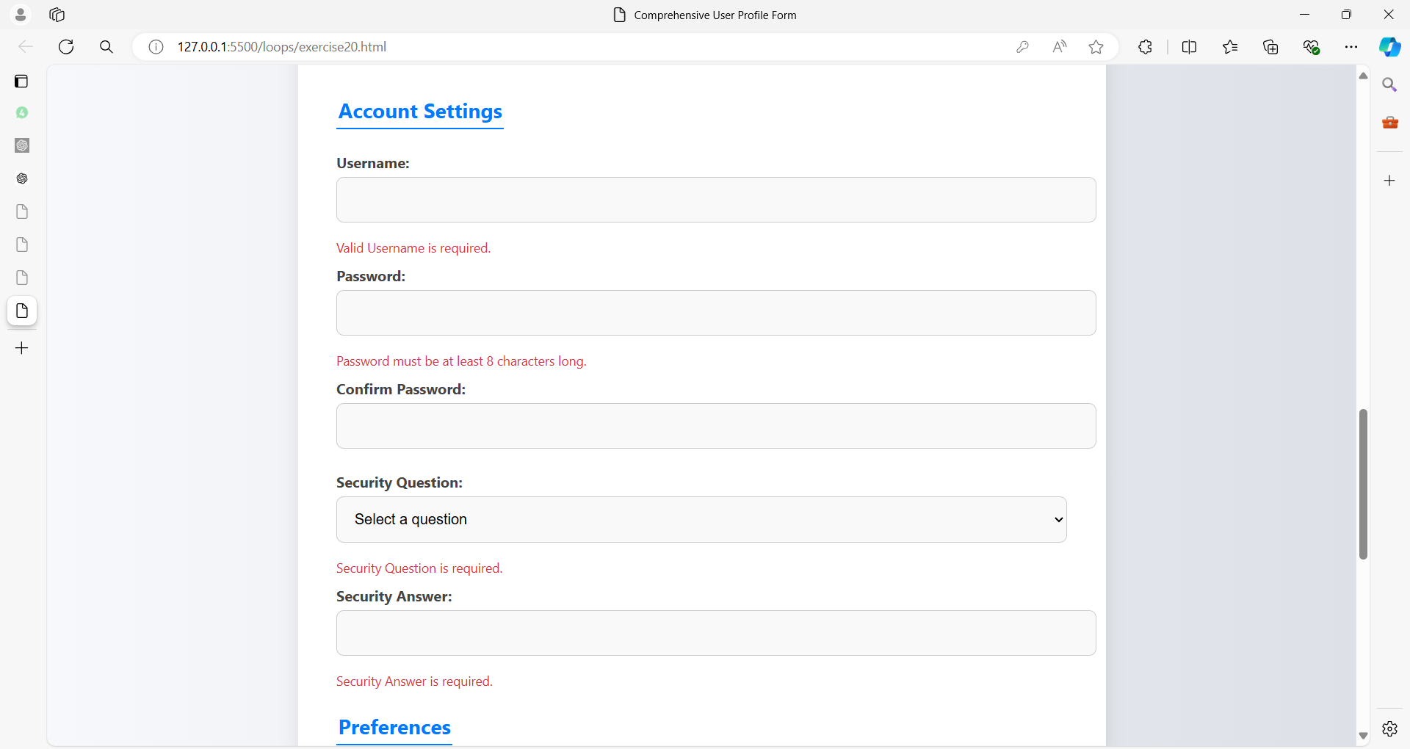

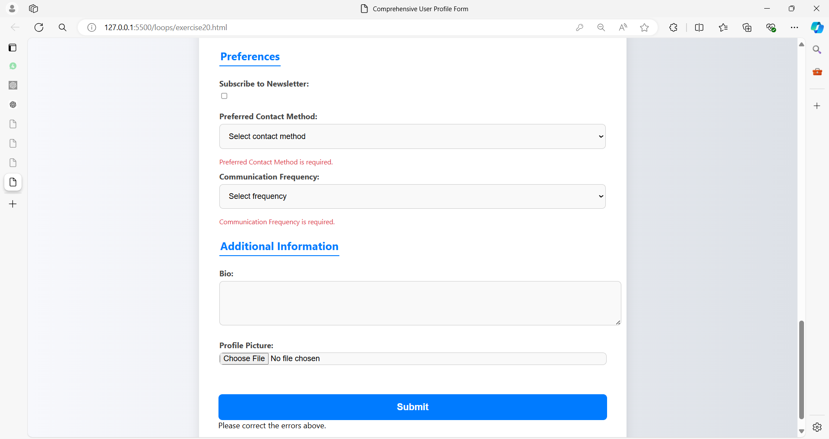

**HTML (profile.html):**

<!DOCTYPE html>

<html lang="en">

<head>

  <meta charset="UTF-8">

  <meta name="viewport" content="width=device-width, initial-scale=1.0">

  <title>Comprehensive User Profile Form</title>

  <link rel="stylesheet" href="styles20.css">

</head>

<body>

  <form id="userProfileForm">

    <h2>User Profile</h2>

    <!-- Personal Information -->

    <fieldset>

      <legend>Personal Information</legend>

      <label for="fullName">Full Name:</label>

      <input type="text" id="fullName" name="fullName" required>

      <span class="error" id="fullNameError"></span>

      <label for="email">Email:</label>

      <input type="email" id="email" name="email" required>

      <span class="error" id="emailError"></span>

      <label for="phone">Phone Number:</label>

      <input type="tel" id="phone" name="phone" pattern="\d{10}" required>

      <span class="error" id="phoneError"></span>

      <label for="dob">Date of Birth:</label>

      <input type="date" id="dob" name="dob" required>

      <span class="error" id="dobError"></span>

      <label>Gender:</label>

      <input type="radio" id="male" name="gender" value="Male" required>

      <label for="male">Male</label>

      <input type="radio" id="female" name="gender" value="Female" required>

      <label for="female">Female</label>

      <input type="radio" id="other" name="gender" value="Other" required>

      <label for="other">Other</label>

      <span class="error" id="genderError"></span>

    </fieldset>

    <!-- Address Information -->

    <fieldset>

      <legend>Address Information</legend>

      <label for="street">Street Address:</label>

      <input type="text" id="street" name="street" required>

      <span class="error" id="streetError"></span>

      <label for="city">City:</label>

      <input type="text" id="city" name="city" required>

      <span class="error" id="cityError"></span>

      <label for="state">State:</label>

      <input type="text" id="state" name="state" required>

      <span class="error" id="stateError"></span>

      <label for="zip">Zip Code:</label>

      <input type="text" id="zip" name="zip" pattern="\d{5}" required>

      <span class="error" id="zipError"></span>

      <label for="country">Country:</label>

      <input type="text" id="country" name="country" required>

      <span class="error" id="countryError"></span>

    </fieldset>

    <!-- Account Settings -->

    <fieldset>

      <legend>Account Settings</legend>

      <label for="username">Username:</label>

      <input type="text" id="username" name="username" pattern="[A-Za-z0-9]+" required>

      <span class="error" id="usernameError"></span>

      <label for="password">Password:</label>

      <input type="password" id="password" name="password" minlength="8" required>

      <span class="error" id="passwordError"></span>

      <label for="confirmPassword">Confirm Password:</label>

      <input type="password" id="confirmPassword" name="confirmPassword" required>

      <span class="error" id="confirmPasswordError"></span>

      <label for="securityQuestion">Security Question:</label>

      <select id="securityQuestion" name="securityQuestion" required>

        <option value="" disabled selected>Select a question</option>

        <option value="motherMaidenName">What is your mother's maiden name?</option>

        <option value="firstPet">What was the name of your first pet?</option>

        <option value="firstSchool">What was the name of your first school?</option>

      </select>

      <span class="error" id="securityQuestionError"></span>

      <label for="securityAnswer">Security Answer:</label>

      <input type="text" id="securityAnswer" name="securityAnswer" required>

      <span class="error" id="securityAnswerError"></span>

    </fieldset>

    <!-- Preferences -->

    <fieldset>

      <legend>Preferences</legend>

      <label for="newsletter">Subscribe to Newsletter:</label>

      <input type="checkbox" id="newsletter" name="newsletter">

      <label for="contactMethod">Preferred Contact Method:</label>

      <select id="contactMethod" name="contactMethod" required>

        <option value="" disabled selected>Select contact method</option>

        <option value="email">Email</option>

        <option value="phone">Phone</option>

        <option value="post">Post</option>

      </select>

      <span class="error" id="contactMethodError"></span>

      <label for="communicationFrequency">Communication Frequency:</label>

      <select id="communicationFrequency" name="communicationFrequency" required>

        <option value="" disabled selected>Select frequency</option>

        <option value="daily">Daily</option>

        <option value="weekly">Weekly</option>

        <option value="monthly">Monthly</option>

      </select>

      <span class="error" id="communicationFrequencyError"></span>

    </fieldset>

    <!-- Additional Information -->

    <fieldset>

      <legend>Additional Information</legend>

      <label for="bio">Bio:</label>

      <textarea id="bio" name="bio" rows="4"></textarea>

      <label for="profilePicture">Profile Picture:</label>

      <input type="file" id="profilePicture" name="profilePicture" accept="image/*">

    </fieldset>

    <button type="button" onclick="validateProfileForm()">Submit</button>

    <div id="formOutput"></div>

  </form>

  <script src="script20.js"></script>

</body>

</html>

**CSS (styles20.css):**

body {

    font-family: 'Segoe UI', Tahoma, Geneva, Verdana, sans-serif;

    background: linear-gradient(to right, #f7f8fc, #dde1e7);

    margin: 0;

    padding: 20px;

    display: flex;

    justify-content: center;

    align-items: flex-start;

    min-height: 100vh;

    box-sizing: border-box;

}

form {

    background-color: #ffffff;

    padding: 40px;

    border-radius: 12px;

    box-shadow: 0px 4px 20px rgba(0, 0, 0, 0.1);

    width: 100%;

    max-width: 800px;

}

h2 {

    text-align: center;

    font-size: 2em;

    color: #333;

    margin-bottom: 20px;

    position: relative;

}

h2::after {

    content: '';

    width: 60px;

    height: 4px;

    background: #007bff;

    display: block;

    margin: 10px auto 0;

    border-radius: 4px;

}

fieldset {

    border: none;

    margin-bottom: 25px;

    padding: 0;

}

legend {

    font-size: 1.4em;

    margin-bottom: 15px;

    color: #007bff;

    font-weight: bold;

    border-bottom: 2px solid #007bff;

    padding-bottom: 5px;

}

label {

    display: block;

    margin: 10px 0 5px;

    font-weight: bold;

    color: #444;

}

input, select, textarea {

    width: 100%;

    padding: 15px;

    margin-bottom: 15px;

    border: 1px solid #ccc;

    border-radius: 8px;

    background-color: #f9f9f9;

    font-size: 1em;

    transition: border-color 0.3s ease, box-shadow 0.3s ease;

}

input:focus, select:focus, textarea:focus {

    border-color: #007bff;

    box-shadow: 0 0 8px rgba(0, 123, 255, 0.2);

    outline: none;

}

input[type="radio"], input[type="checkbox"] {

    width: auto;

    margin-right: 10px;

    cursor: pointer;

}

input[type="file"] {

    padding: 0;

}

button {

    width: 100%;

    padding: 15px;

    background-color: #007bff;

    border: none;

    border-radius: 8px;

    color: white;

    font-size: 1.2em;

    font-weight: bold;

    cursor: pointer;

    transition: background-color 0.3s ease, box-shadow 0.3s ease;

    margin-top: 20px;

}

button:hover {

    background-color: #0056b3;

    box-shadow: 0 0 12px rgba(0, 123, 255, 0.3);

}

.error {

    color: #dc3545;

    font-size: 0.875em;

    margin-top: -10px;

    margin-bottom: 10px;

}

textarea {

    resize: vertical;

}

@media screen and (max-width: 600px) {

    form {

        padding: 20px;

    }

    legend {

        font-size: 1.2em;

    }

}

**JavaScript (script20.js):**

document.addEventListener('DOMContentLoaded', () => {

    // Add event listeners to all inputs to remove error messages on change

    document.querySelectorAll('input, select, textarea').forEach(input => {

        input.addEventListener('input', clearErrorMessage);

        input.addEventListener('change', clearErrorMessage);

    });

    function clearErrorMessage(event) {

        const errorElement = document.getElementById(event.target.id + 'Error');

        if (errorElement) {

            errorElement.textContent = '';

        }

    }

});

function validateProfileForm() {

    let valid = true;

    // Clear previous errors

    document.querySelectorAll('.error').forEach(e => e.textContent = '');

    // Validate Full Name

    const fullName = document.getElementById('fullName').value;

    if (!fullName) {

        document.getElementById('fullNameError').textContent = 'Full Name is required.';

        valid = false;

    }

    // Validate Email

    const email = document.getElementById('email').value;

    if (!email || !validateEmail(email)) {

        document.getElementById('emailError').textContent = 'A valid Email is required.';

        valid = false;

    }

    // Validate Phone Number

    const phone = document.getElementById('phone').value;

    if (!phone || !/^\d{10}$/.test(phone)) {

        document.getElementById('phoneError').textContent = 'Phone Number must be 10 digits.';

        valid = false;

    }

    // Validate Date of Birth

    const dob = document.getElementById('dob').value;

    if (!dob) {

        document.getElementById('dobError').textContent = 'Date of Birth is required.';

        valid = false;

    }

    // Validate Gender

    const gender = document.querySelector('input[name="gender"]:checked');

    if (!gender) {

        document.getElementById('genderError').textContent = 'Gender is required.';

        valid = false;

    }

    // Validate Address Information

    const street = document.getElementById('street').value;

    const city = document.getElementById('city').value;

    const state = document.getElementById('state').value;

    const zip = document.getElementById('zip').value;

    const country = document.getElementById('country').value;

    if (!street || !city || !state || !zip || !country) {

        document.getElementById('streetError').textContent = 'All address fields are required.';

        valid = false;

    }

    if (!/^\d{5}$/.test(zip)) {

        document.getElementById('zipError').textContent = 'Zip Code must be 5 digits.';

        valid = false;

    }

    // Validate Account Settings

    const username = document.getElementById('username').value;

    const password = document.getElementById('password').value;

    const confirmPassword = document.getElementById('confirmPassword').value;

    const securityQuestion = document.getElementById('securityQuestion').value;

    const securityAnswer = document.getElementById('securityAnswer').value;

    if (!username || !/^[A-Za-z0-9]+$/.test(username)) {

        document.getElementById('usernameError').textContent = 'Valid Username is required.';

        valid = false;

    }

    if (!password || password.length < 8) {

        document.getElementById('passwordError').textContent = 'Password must be at least 8 characters long.';

        valid = false;

    }

    if (password !== confirmPassword) {

        document.getElementById('confirmPasswordError').textContent = 'Passwords must match.';

        valid = false;

    }

    if (!securityQuestion) {

        document.getElementById('securityQuestionError').textContent = 'Security Question is required.';

        valid = false;

    }

    if (!securityAnswer) {

        document.getElementById('securityAnswerError').textContent = 'Security Answer is required.';

        valid = false;

    }

    // Validate Preferences

    const contactMethod = document.getElementById('contactMethod').value;

    const communicationFrequency = document.getElementById('communicationFrequency').value;

    if (!contactMethod) {

        document.getElementById('contactMethodError').textContent = 'Preferred Contact Method is required.';

        valid = false;

    }

    if (!communicationFrequency) {

        document.getElementById('communicationFrequencyError').textContent = 'Communication Frequency is required.';

        valid = false;

    }

    // Output

    if (valid) {

        document.getElementById('formOutput').textContent = 'Form submitted successfully!';

    } else {

        document.getElementById('formOutput').textContent = 'Please correct the errors above.';

    }

}

function validateEmail(email) {

    const re = /^[^\s@]+@[^\s@]+\.[^\s@]+$/;

    return re.test(String(email).toLowerCase());

}

**Exercise 21: Multi-Step Survey Form**

**Question:** Develop a multi-step survey form with the following sections:

1. **Personal Information:**
   * First Name (required)
   * Last Name (required)
   * Email (required, valid email format)
   * Age (required, numeric)
   * Gender (required, options: Male, Female, Non-Binary, Prefer not to say)
2. **Survey Questions:**
   * How did you hear about us? (required, options: Internet, Friend, Advertisement, Other)
   * What products are you interested in? (required, checkboxes: Electronics, Clothing, Home Goods, Other)
   * Rate your experience with our website (required, scale 1-5)
   * Additional Comments (optional, textarea)
3. **Feedback and Preferences:**
   * Would you recommend us to a friend? (required, Yes/No)
   * What can we improve? (optional, textarea)
   * Preferred Contact Method (required, options: Email, Phone, None)

**Requirements:**

1. Style the form with CSS to ensure clarity and ease of use across different steps.
2. Implement JavaScript to:
   * Manage multi-step navigation (show/hide steps).
   * Validate each step's fields before allowing progress to the next step.
   * Validate all inputs according to their respective requirements.
   * Display appropriate error messages and success messages at each stage.
3. Provide a summary of responses at the end of the form.

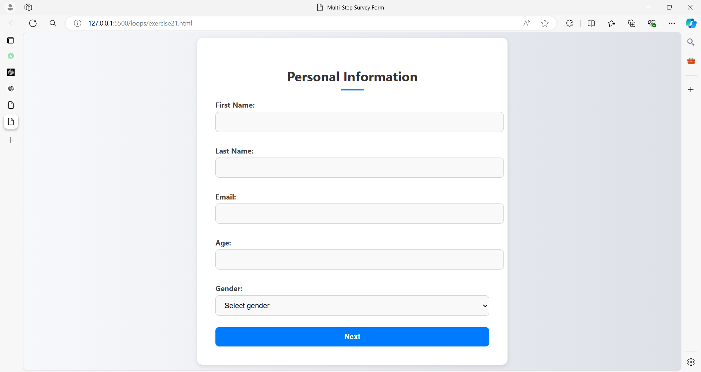

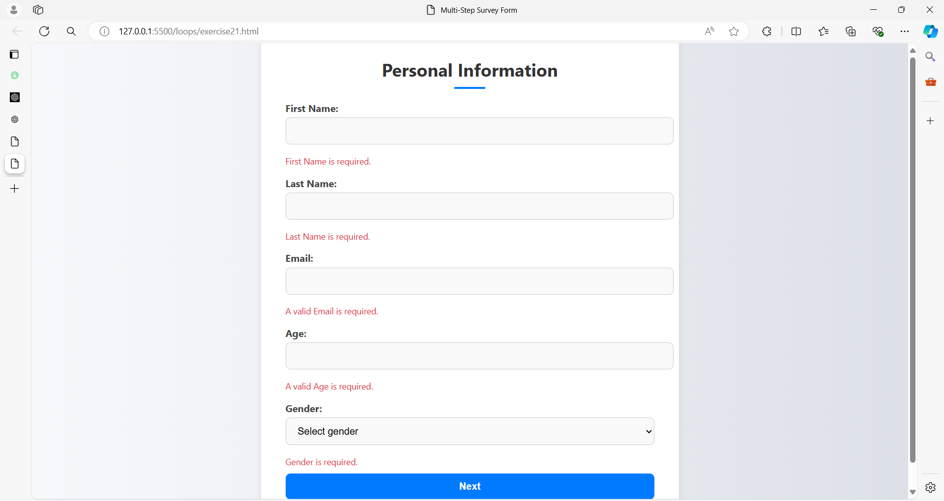

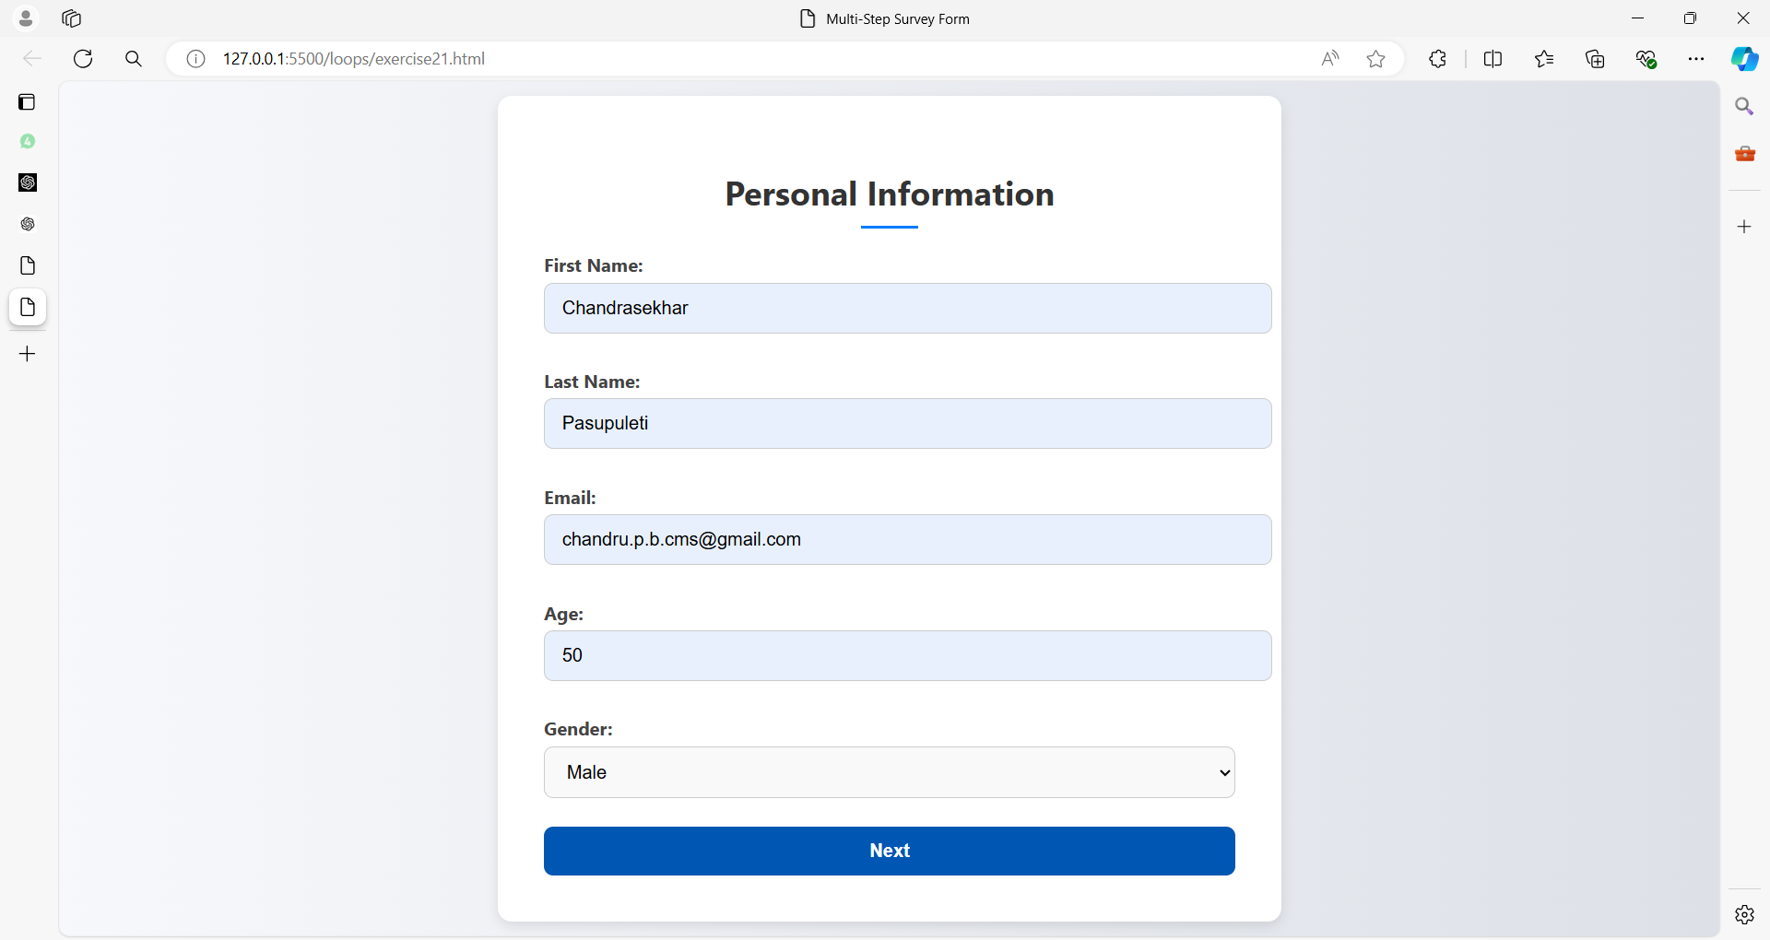

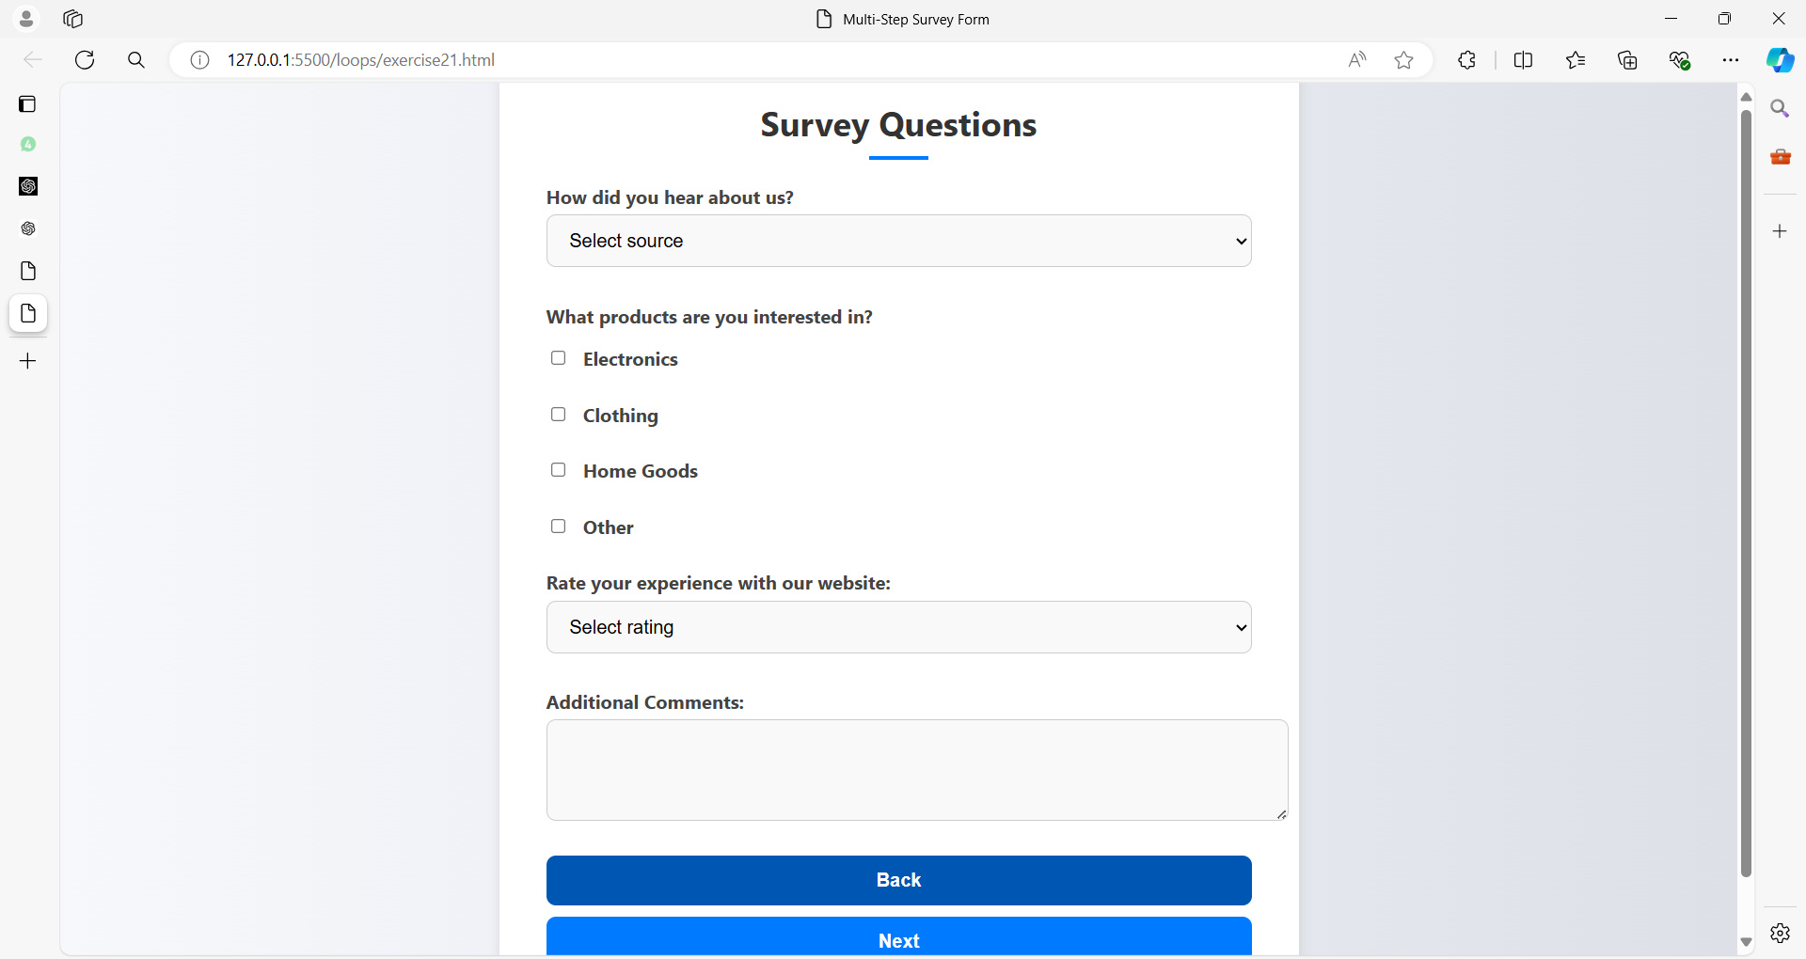

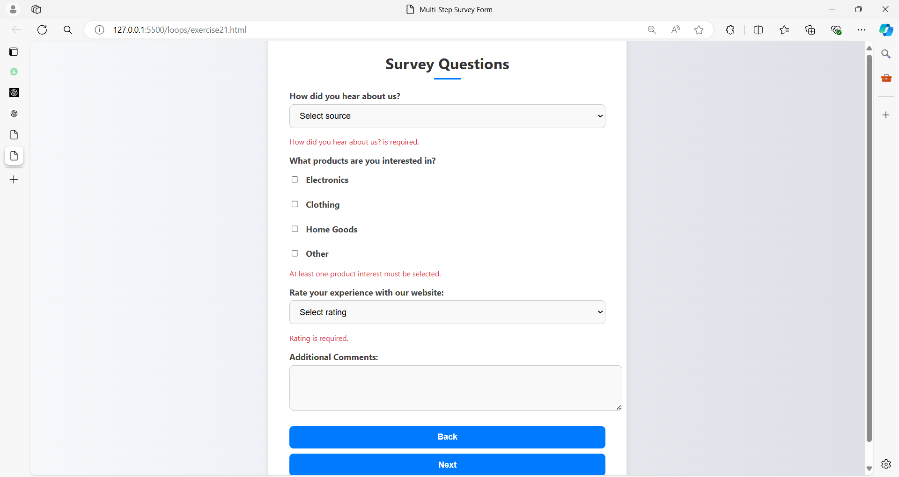

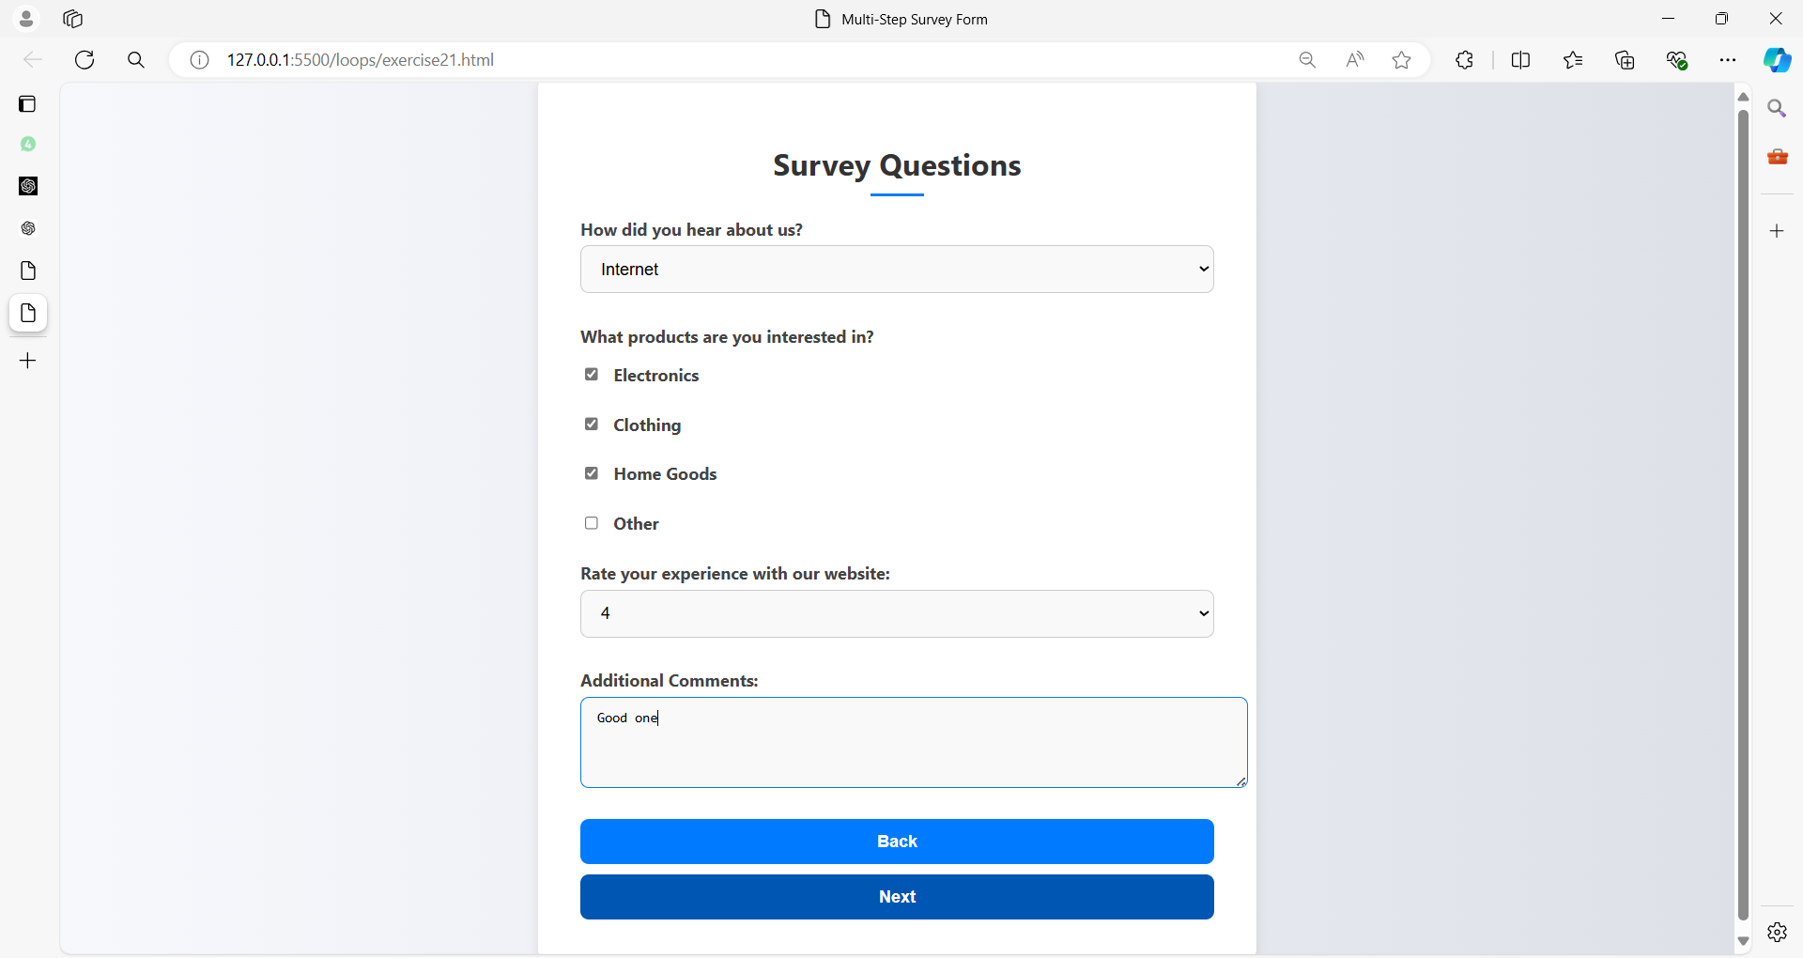

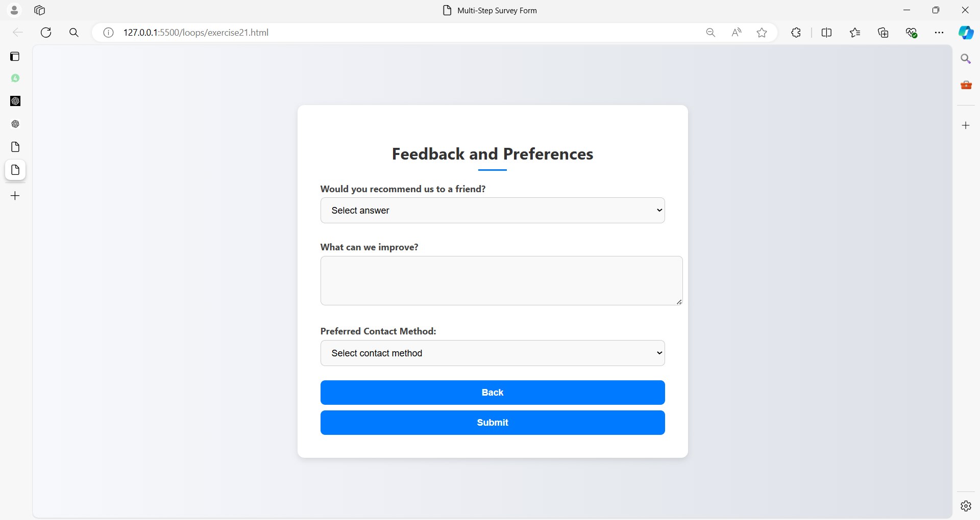

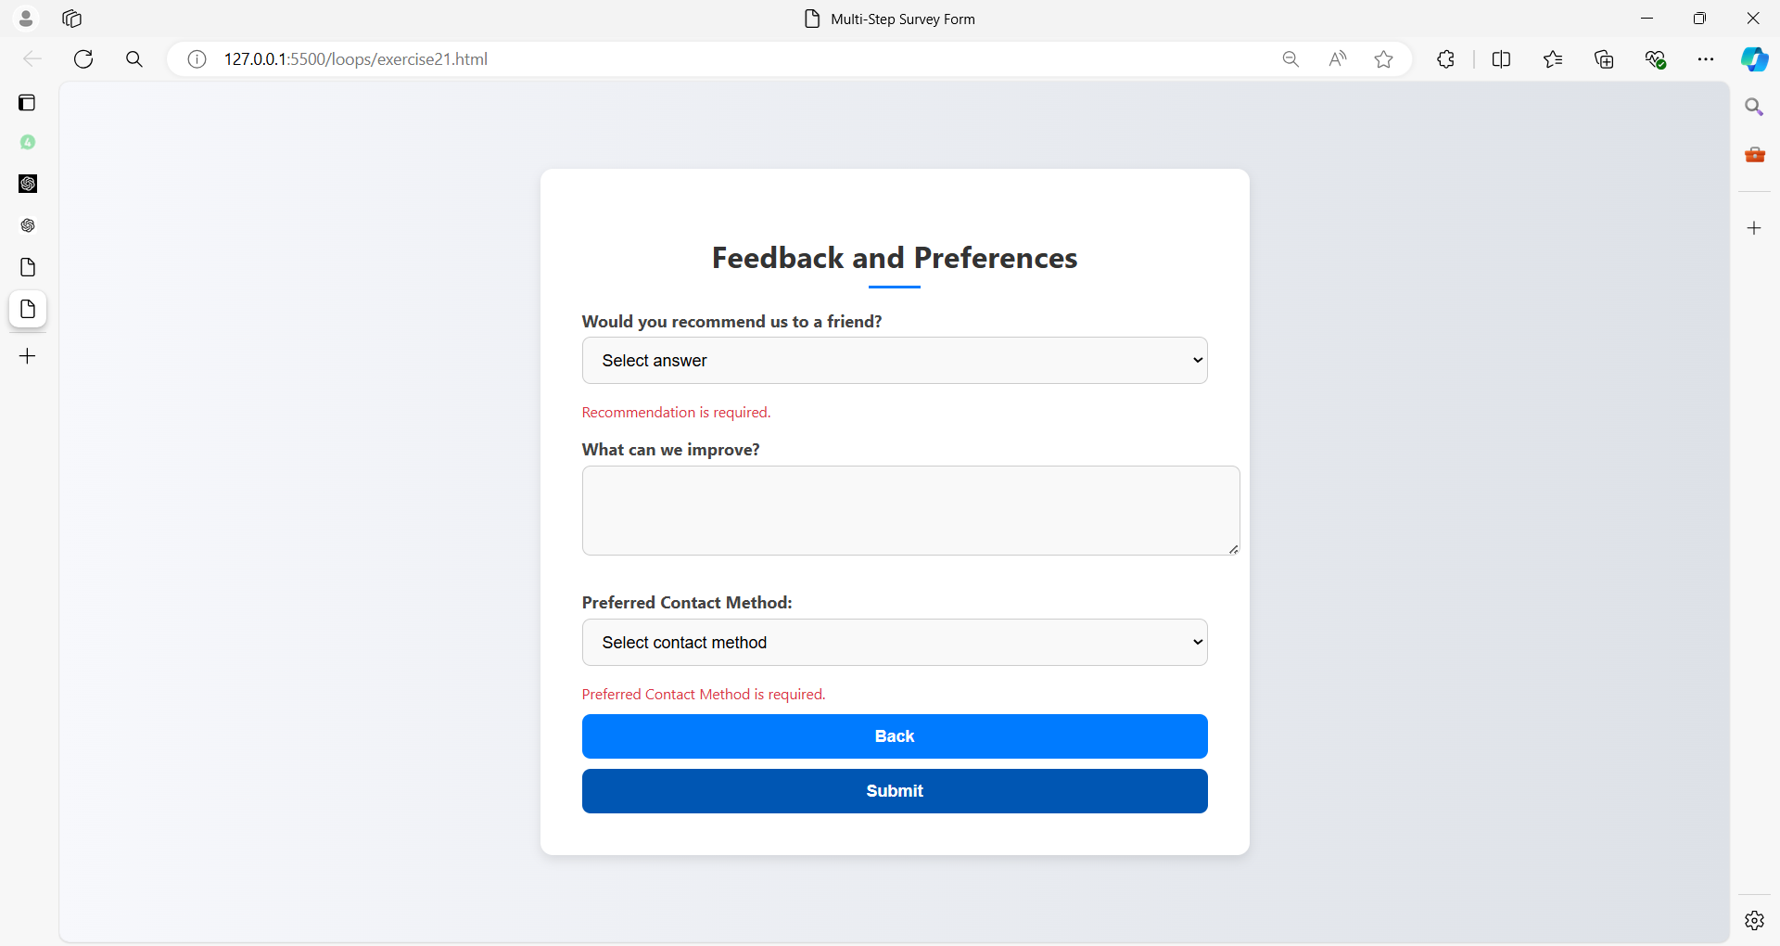

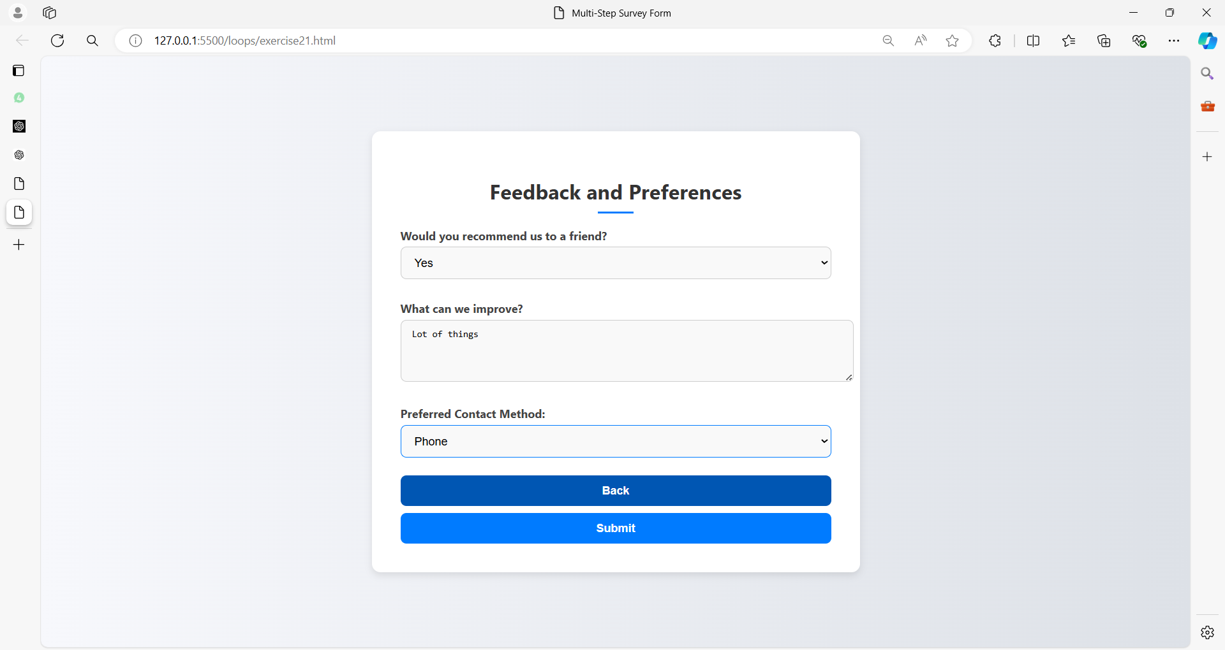

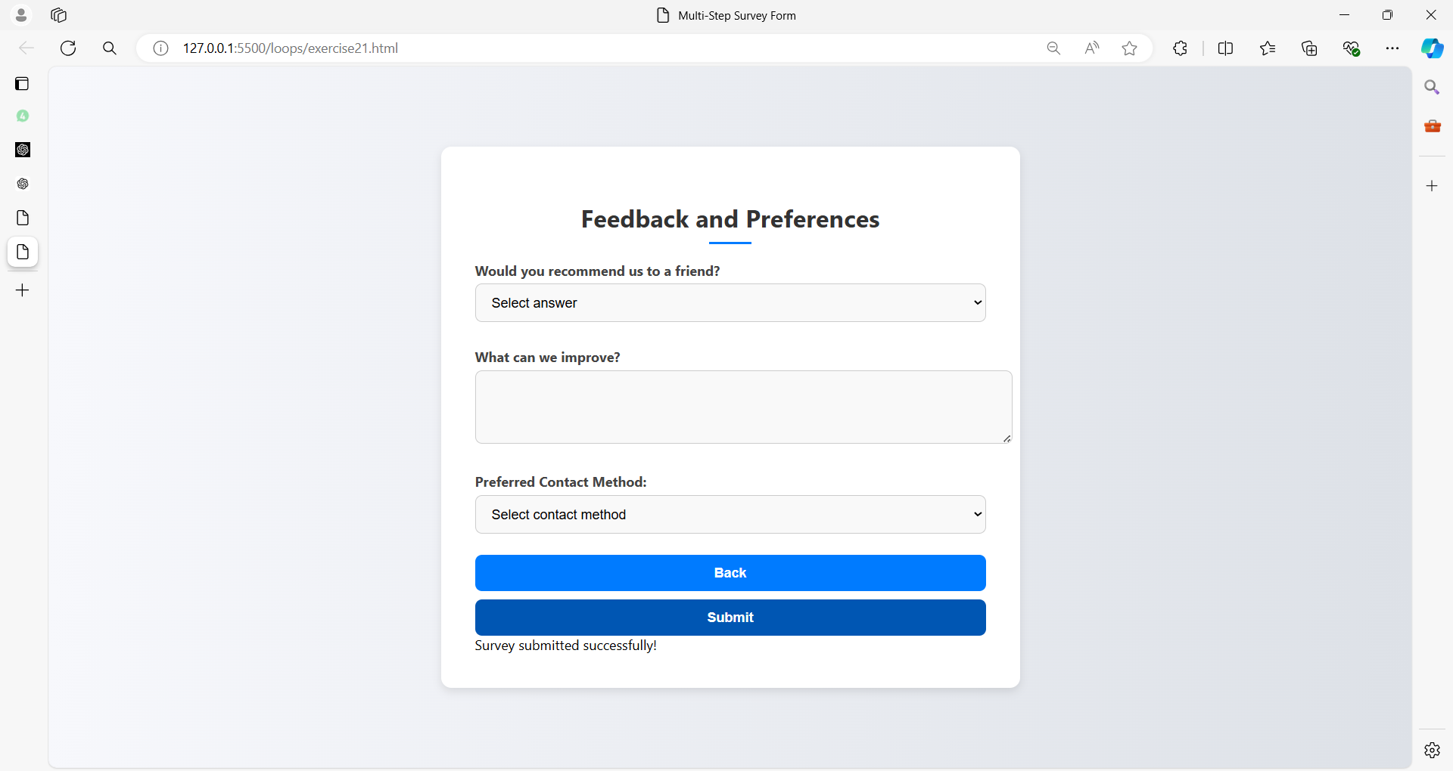

**HTML (multi-step-survey.html):**

<!DOCTYPE html>

<html lang="en">

<head>

  <meta charset="UTF-8">

  <meta name="viewport" content="width=device-width, initial-scale=1.0">

  <title>Multi-Step Survey Form</title>

  <link rel="stylesheet" href="styles21.css">

</head>

<body>

  <form id="surveyForm">

    <!-- Step 1: Personal Information -->

    <div id="step1" class="form-step">

      <h2>Personal Information</h2>

      <label for="firstName">First Name:</label>

      <input type="text" id="firstName" name="firstName" required>

      <span class="error" id="firstNameError"></span>

      <label for="lastName">Last Name:</label>

      <input type="text" id="lastName" name="lastName" required>

      <span class="error" id="lastNameError"></span>

      <label for="email">Email:</label>

      <input type="email" id="email" name="email" required>

      <span class="error" id="emailError"></span>

      <label for="age">Age:</label>

      <input type="number" id="age" name="age" required min="1">

      <span class="error" id="ageError"></span>

      <label for="gender">Gender:</label>

      <select id="gender" name="gender" required>

        <option value="" disabled selected>Select gender</option>

        <option value="male">Male</option>

        <option value="female">Female</option>

        <option value="non-binary">Non-Binary</option>

        <option value="prefer-not-to-say">Prefer not to say</option>

      </select>

      <span class="error" id="genderError"></span>

      <button type="button" onclick="showStep(2)">Next</button>

    </div>

    <!-- Step 2: Survey Questions -->

    <div id="step2" class="form-step" style="display:none;">

      <h2>Survey Questions</h2>

      <label for="source">How did you hear about us?</label>

      <select id="source" name="source" required>

        <option value="" disabled selected>Select source</option>

        <option value="internet">Internet</option>

        <option value="friend">Friend</option>

        <option value="advertisement">Advertisement</option>

        <option value="other">Other</option>

      </select>

      <span class="error" id="sourceError"></span>

      <label>What products are you interested in?</label>

      <label><input type="checkbox" name="products" value="electronics"> Electronics</label>

      <label><input type="checkbox" name="products" value="clothing"> Clothing</label>

      <label><input type="checkbox" name="products" value="home-goods"> Home Goods</label>

      <label><input type="checkbox" name="products" value="other"> Other</label>

      <span class="error" id="productsError"></span>

      <label for="experience">Rate your experience with our website:</label>

      <select id="experience" name="experience" required>

        <option value="" disabled selected>Select rating</option>

        <option value="1">1</option>

        <option value="2">2</option>

        <option value="3">3</option>

        <option value="4">4</option>

        <option value="5">5</option>

      </select>

      <span class="error" id="experienceError"></span>

      <label for="comments">Additional Comments:</label>

      <textarea id="comments" name="comments" rows="4"></textarea>

      <button type="button" onclick="showStep(1)">Back</button>

      <button type="button" onclick="showStep(3)">Next</button>

    </div>

    <!-- Step 3: Feedback and Preferences -->

    <div id="step3" class="form-step" style="display:none;">

      <h2>Feedback and Preferences</h2>

      <label for="recommend">Would you recommend us to a friend?</label>

      <select id="recommend" name="recommend" required>

        <option value="" disabled selected>Select answer</option>

        <option value="yes">Yes</option>

        <option value="no">No</option>

      </select>

      <span class="error" id="recommendError"></span>

      <label for="improvements">What can we improve?</label>

      <textarea id="improvements" name="improvements" rows="4"></textarea>

      <label for="contactMethod">Preferred Contact Method:</label>

      <select id="contactMethod" name="contactMethod" required>

        <option value="" disabled selected>Select contact method</option>

        <option value="email">Email</option>

        <option value="phone">Phone</option>

        <option value="none">None</option>

      </select>

      <span class="error" id="contactMethodError"></span>

      <button type="button" onclick="showStep(2)">Back</button>

      <button type="button" onclick="validateSurveyForm()">Submit</button>

    </div>

    <div id="surveyOutput"></div>

  </form>

  <script src="script21.js"></script>

</body>

</html>

**CSS (styles21.css):**

body {

  font-family: 'Segoe UI', Tahoma, Geneva, Verdana, sans-serif;

  background: linear-gradient(to right, #f7f8fc, #dde1e7);

  margin: 0;

  padding: 0;

  display: flex;

  justify-content: center;

  align-items: center;

  height: 100vh;

}

form {

  background-color: #ffffff;

  padding: 40px;

  border-radius: 12px;

  box-shadow: 0px 4px 10px rgba(0, 0, 0, 0.1);

  width: 100%;

  max-width: 600px;

}

h2 {

  text-align: center;

  font-size: 1.8em;

  color: #333;

  margin-bottom: 20px;

  position: relative;

}

h2::after {

  content: '';

  width: 50px;

  height: 3px;

  background: #007bff;

  display: block;

  margin: 10px auto 0;

}

label {

  display: block;

  margin: 15px 0 5px;

  font-weight: bold;

  color: #444;

}

input, select, textarea {

  width: 100%;

  padding: 12px 15px;

  margin-bottom: 15px;

  border: 1px solid #ccc;

  border-radius: 8px;

  background-color: #f9f9f9;

  font-size: 1em;

  transition: border-color 0.3s ease;

}

input:focus, select:focus, textarea:focus {

  border-color: #007bff;

  outline: none;

}

input[type="checkbox"] {

  width: auto;

  margin-right: 10px;

  cursor: pointer;

}

button {

  width: 100%;

  padding: 12px;

  background-color: #007bff;

  border: none;

  border-radius: 8px;

  color: white;

  font-size: 1em;

  font-weight: bold;

  cursor: pointer;

  transition: background-color 0.3s ease;

  margin-top: 10px;

}

button:hover {

  background-color: #0056b3;

}

.error {

  color: #dc3545;

  font-size: 0.875em;

  margin-top: -10px;

  margin-bottom: 10px;

}

.form-step {

  animation: fadeIn 0.5s ease-in-out;

}

@keyframes fadeIn {

  from { opacity: 0; }

  to { opacity: 1; }

}

@media screen and (max-width: 600px) {

  form {

      padding: 20px;

  }

}

**JavaScript (script21.js):**

function showStep(step) {

  // Validate the current step before showing the next one

  let valid = true;

  if (step === 2) {

    if (!validateFirstName()) valid = false;

    if (!validateLastName()) valid = false;

    if (!validateEmailField()) valid = false;

    if (!validateAge()) valid = false;

    if (!validateGender()) valid = false;

  } else if (step === 3) {

    if (!validateSource()) valid = false;

    if (!validateProducts()) valid = false;

    if (!validateExperience()) valid = false;

  }

  // If the current step is valid, show the next step

  if (valid) {

    // Hide all steps

    document.querySelectorAll('.form-step').forEach(s => s.style.display = 'none');

    // Show the requested step

    document.getElementById(`step${step}`).style.display = 'block';

  }

}

document.addEventListener('DOMContentLoaded', function() {

  // Add event listeners for immediate validation

  document.getElementById('firstName').addEventListener('input', validateFirstName);

  document.getElementById('lastName').addEventListener('input', validateLastName);

  document.getElementById('email').addEventListener('input', validateEmailField);

  document.getElementById('age').addEventListener('input', validateAge);

  document.getElementById('gender').addEventListener('change', validateGender);

  document.getElementById('source').addEventListener('change', validateSource);

  document.querySelectorAll('input[name="products"]').forEach(el => el.addEventListener('change', validateProducts));

  document.getElementById('experience').addEventListener('change', validateExperience);

  document.getElementById('recommend').addEventListener('change', validateRecommend);

  document.getElementById('contactMethod').addEventListener('change', validateContactMethod);

});

function validateSurveyForm() {

  let valid = true;

  // Clear previous errors if already valid

  if (!validateFirstName()) valid = false;

  if (!validateLastName()) valid = false;

  if (!validateEmailField()) valid = false;

  if (!validateAge()) valid = false;

  if (!validateGender()) valid = false;

  if (!validateSource()) valid = false;

  if (!validateProducts()) valid = false;

  if (!validateExperience()) valid = false;

  if (!validateRecommend()) valid = false;

  if (!validateContactMethod()) valid = false;

  if (valid) {

    document.getElementById('surveyOutput').textContent = 'Survey submitted successfully!';

    document.getElementById('surveyForm').reset();

  }

}

// Individual validation functions

function validateFirstName() {

  const firstName = document.getElementById('firstName').value;

  if (!firstName) {

    document.getElementById('firstNameError').textContent = 'First Name is required.';

    return false;

  } else {

    document.getElementById('firstNameError').textContent = '';

    return true;

  }

}

function validateLastName() {

  const lastName = document.getElementById('lastName').value;

  if (!lastName) {

    document.getElementById('lastNameError').textContent = 'Last Name is required.';

    return false;

  } else {

    document.getElementById('lastNameError').textContent = '';

    return true;

  }

}

function validateEmailField() {

  const email = document.getElementById('email').value;

  if (!email || !validateEmail(email)) {

    document.getElementById('emailError').textContent = 'A valid Email is required.';

    return false;

  } else {

    document.getElementById('emailError').textContent = '';

    return true;

  }

}

function validateAge() {

  const age = document.getElementById('age').value;

  if (!age || age < 1) {

    document.getElementById('ageError').textContent = 'A valid Age is required.';

    return false;

  } else {

    document.getElementById('ageError').textContent = '';

    return true;

  }

}

function validateGender() {

  const gender = document.getElementById('gender').value;

  if (!gender) {

    document.getElementById('genderError').textContent = 'Gender is required.';

    return false;

  } else {

    document.getElementById('genderError').textContent = '';

    return true;

  }

}

function validateSource() {

  const source = document.getElementById('source').value;

  if (!source) {

    document.getElementById('sourceError').textContent = 'How did you hear about us? is required.';

    return false;

  } else {

    document.getElementById('sourceError').textContent = '';

    return true;

  }

}

function validateProducts() {

  const products = document.querySelectorAll('input[name="products"]:checked');

  if (products.length === 0) {

    document.getElementById('productsError').textContent = 'At least one product interest must be selected.';

    return false;

  } else {

    document.getElementById('productsError').textContent = '';

    return true;

  }

}

function validateExperience() {

  const experience = document.getElementById('experience').value;

  if (!experience) {

    document.getElementById('experienceError').textContent = 'Rating is required.';

    return false;

  } else {

    document.getElementById('experienceError').textContent = '';

    return true;

  }

}

function validateRecommend() {

  const recommend = document.getElementById('recommend').value;

  if (!recommend) {

    document.getElementById('recommendError').textContent = 'Recommendation is required.';

    return false;

  } else {

    document.getElementById('recommendError').textContent = '';

    return true;

  }

}

function validateContactMethod() {

  const contactMethod = document.getElementById('contactMethod').value;

  if (!contactMethod) {

    document.getElementById('contactMethodError').textContent = 'Preferred Contact Method is required.';

    return false;

  } else {

    document.getElementById('contactMethodError').textContent = '';

    return true;

  }

}

function validateEmail(email) {

  const re = /^[^\s@]+@[^\s@]+\.[^\s@]+$/;

  return re.test(email);

}

**Exercise 22: E-Commerce Checkout Form**

**Question:** Build an e-commerce checkout form that includes:

1. **Customer Information:**
   * Full Name (required)
   * Email (required, valid email format)
   * Phone Number (required, 10 digits)
2. **Shipping Address:**
   * Address Line 1 (required)
   * Address Line 2 (optional)
   * City (required)
   * State (required)
   * Zip Code (required, 5 digits)
   * Country (required)
3. **Payment Information:**
   * Credit Card Number (required, valid format)
   * Expiry Date (required)
   * CVV (required, 3 digits)
   * Billing Address (same as shipping address checkbox)
4. **Order Summary:**
   * Items List (auto-filled based on cart)
   * Quantity (editable)
   * Total Price (auto-calculated)
5. **Additional Options:**
   * Gift Wrap (optional, checkbox)
   * Special Instructions (optional, textarea)

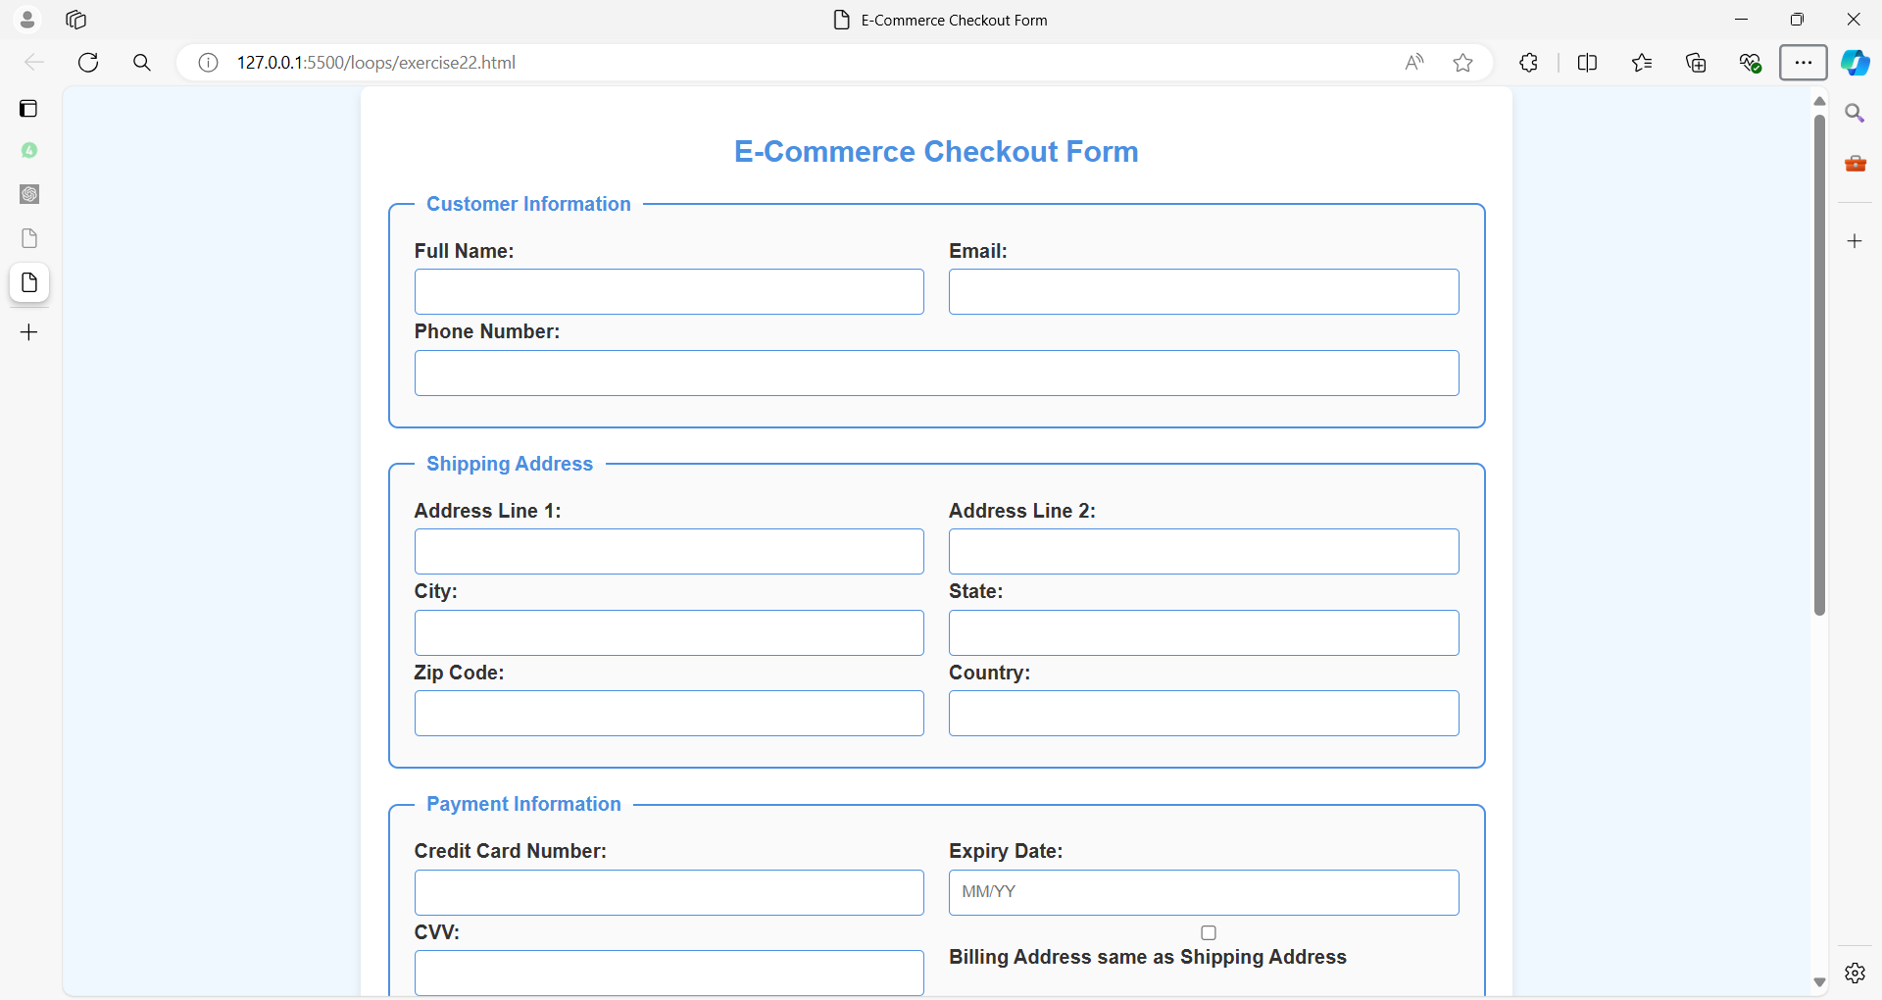

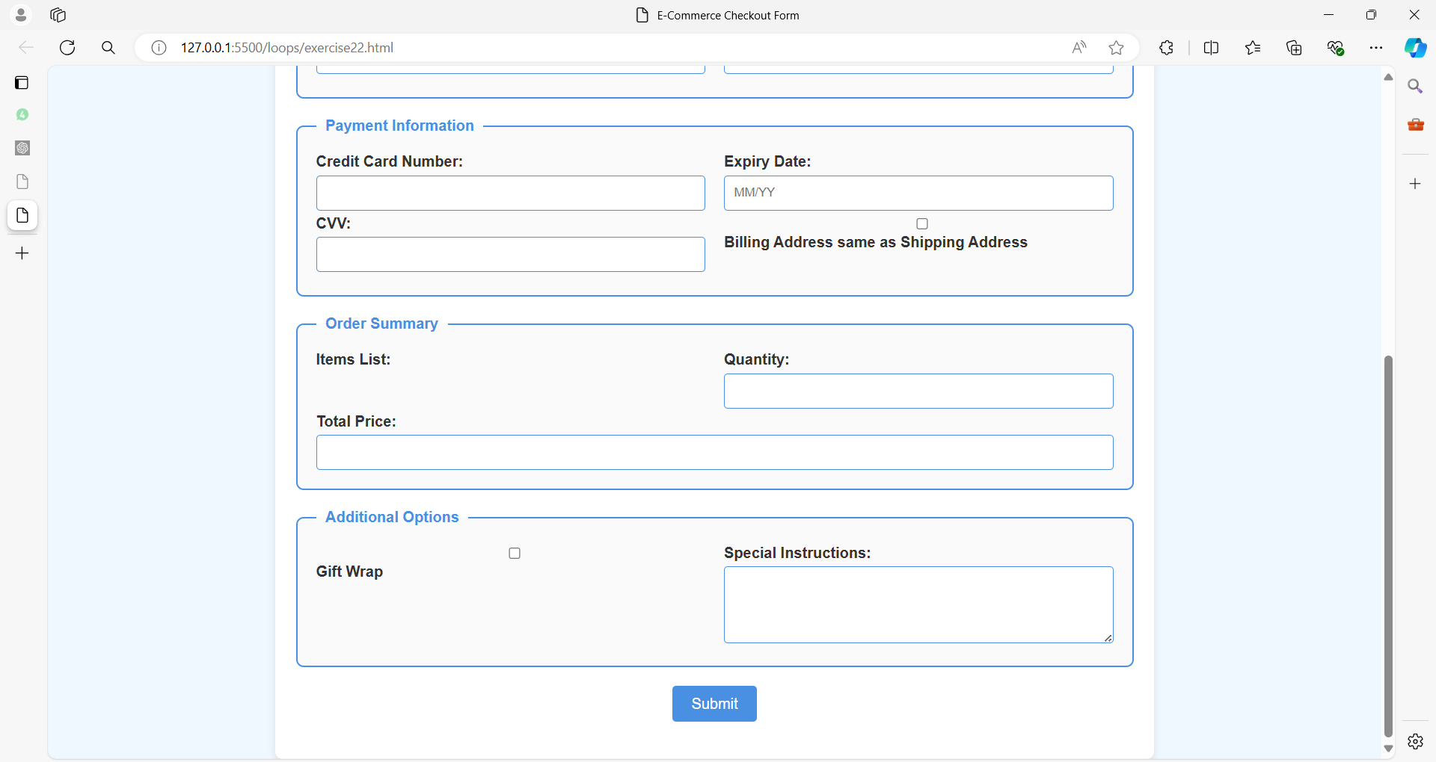

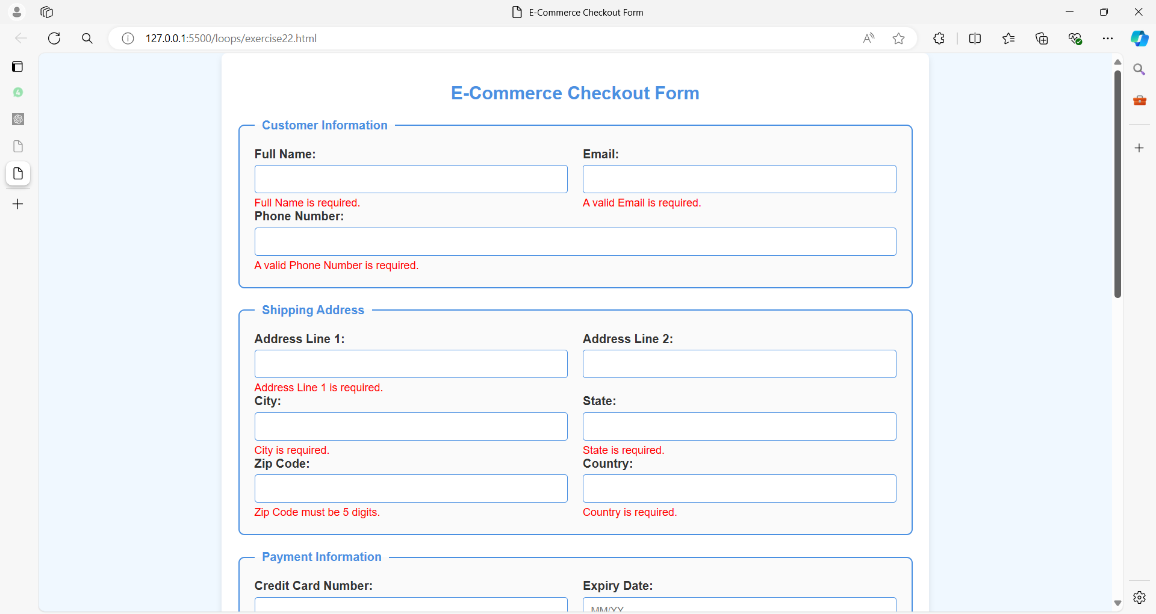

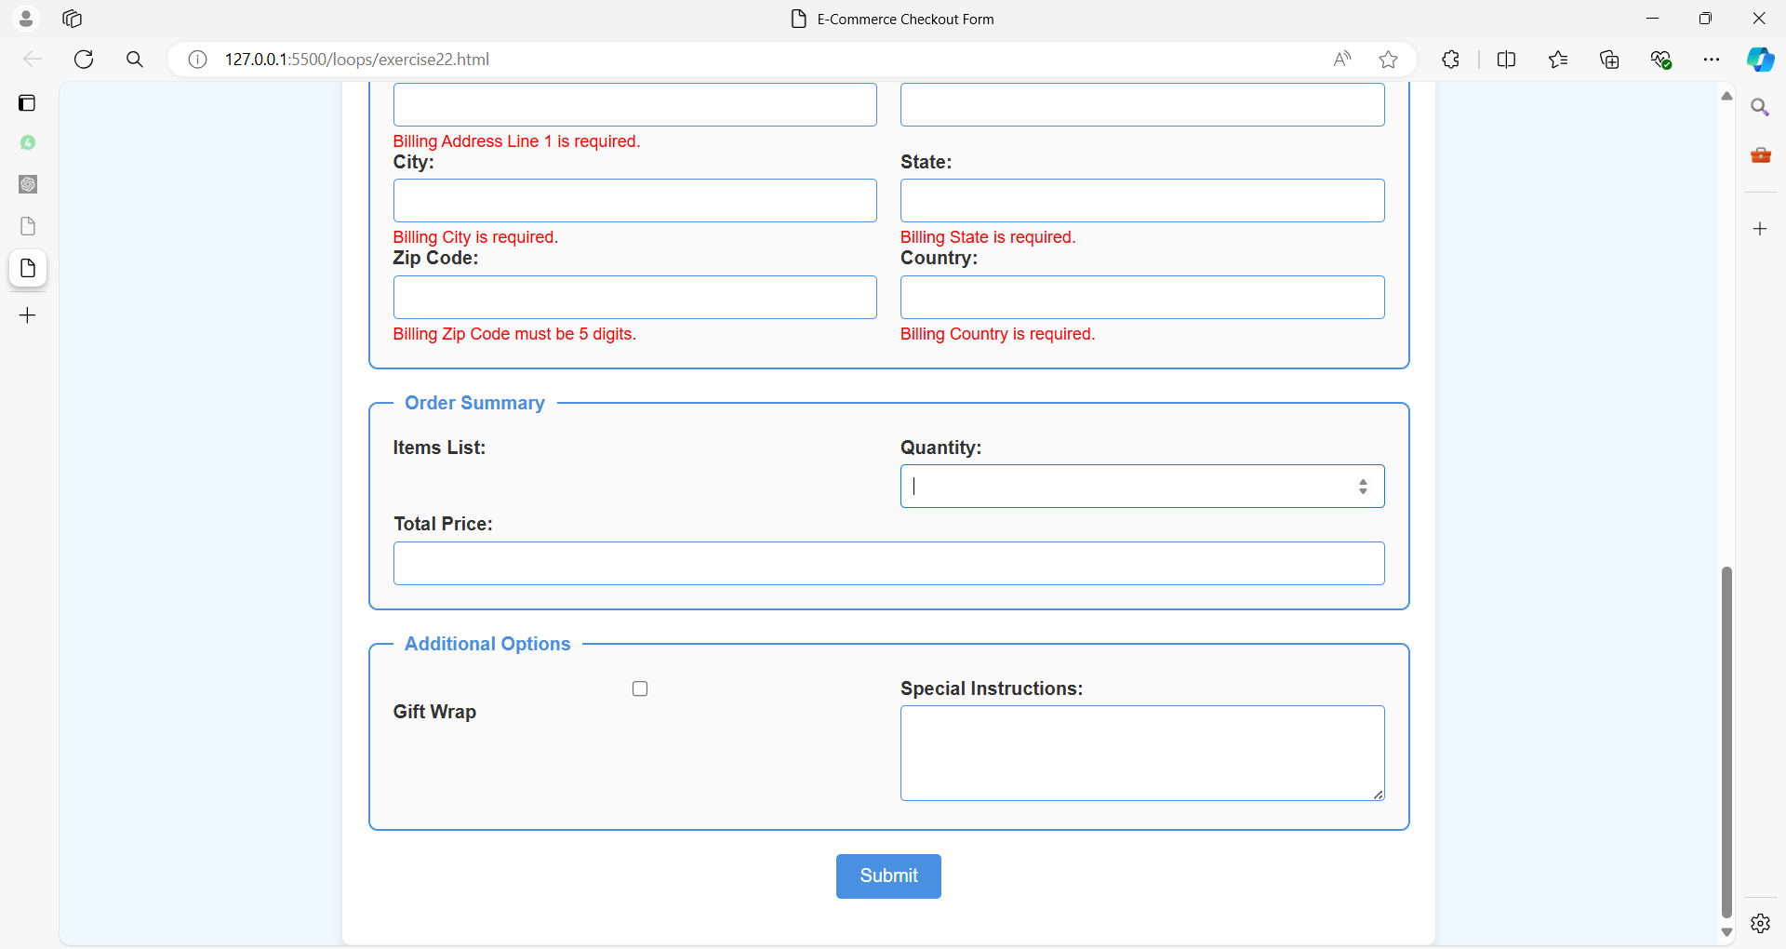

**HTML (checkout-form.html):**

<!DOCTYPE html>

<html lang="en">

<head>

<meta charset="UTF-8">

<meta name="viewport" content="width=device-width, initial-scale=1.0">

<title>E-Commerce Checkout Form</title>

<link rel="stylesheet" href="styles.css">

</head>

<body>

<form id="checkoutForm">

<h2>E-Commerce Checkout Form</h2>

<fieldset>

<legend>Customer Information</legend>

<label for="fullName">Full Name:</label>

<input type="text" id="fullName" name="fullName" required>

<span class="error" id="fullNameError"></span>

<label for="email">Email:</label>

<input type="email" id="email" name="email" required>

<span class="error" id="emailError"></span>

<label for="phoneNumber">Phone Number:</label>

<input type="tel" id="phoneNumber" name="phoneNumber" pattern="\d{10}" required>

<span class="error" id="phoneNumberError"></span>

</fieldset>

<fieldset>

<legend>Shipping Address</legend>

<label for="addressLine1">Address Line 1:</label>

<input type="text" id="addressLine1" name="addressLine1" required>

<span class="error" id="addressLine1Error"></span>

<label for="addressLine2">Address Line 2:</label>

<input type="text" id="addressLine2" name="addressLine2">

<label for="city">City:</label>

<input type="text" id="city" name="city" required>

<span class="error" id="cityError"></span>

<label for="state">State:</label>

<input type="text" id="state" name="state" required>

<span class="error" id="stateError"></span>

<label for="zipCode">Zip Code:</label>

<input type="text" id="zipCode" name="zipCode" pattern="\d{5}" required>

<span class="error" id="zipCodeError"></span>

<label for="country">Country:</label>

<input type="text" id="country" name="country" required>

<span class="error" id="countryError"></span>

</fieldset>

<fieldset>

<legend>Payment Information</legend>

<label for="creditCardNumber">Credit Card Number:</label>

<input type="text" id="creditCardNumber" name="creditCardNumber" pattern="\d{16}" required>

<span class="error" id="creditCardNumberError"></span>

<label for="expiryDate">Expiry Date:</label>

<input type="text" id="expiryDate" name="expiryDate" placeholder="MM/YY" required>

<span class="error" id="expiryDateError"></span>

<label for="cvv">CVV:</label>

<input type="text" id="cvv" name="cvv" pattern="\d{3}" required>

<span class="error" id="cvvError"></span>

<label>

<input type="checkbox" id="sameAsShipping" name="sameAsShipping">

Billing Address same as Shipping Address

</label>

</fieldset>

<fieldset id="billingAddress" style="display:none;">

<legend>Billing Address</legend>

<label for="billingAddressLine1">Address Line 1:</label>

<input type="text" id="billingAddressLine1" name="billingAddressLine1">

<span class="error" id="billingAddressLine1Error"></span>

<label for="billingAddressLine2">Address Line 2:</label>

<input type="text" id="billingAddressLine2" name="billingAddressLine2">

<label for="billingCity">City:</label>

<input type="text" id="billingCity" name="billingCity">

<span class="error" id="billingCityError"></span>

<label for="billingState">State:</label>

<input type="text" id="billingState" name="billingState">

<span class="error" id="billingStateError"></span>

<label for="billingZipCode">Zip Code:</label>

<input type="text" id="billingZipCode" name="billingZipCode" pattern="\d{5}">

<span class="error" id="billingZipCodeError"></span>

<label for="billingCountry">Country:</label>

<input type="text" id="billingCountry" name="billingCountry">

<span class="error" id="billingCountryError"></span>

</fieldset>

<fieldset>

<legend>Order Summary</legend>

<label>Items List:</label>

<ul id="itemsList">

<!-- Items will be dynamically added here -->

</ul>

<label for="quantity">Quantity:</label>

<input type="number" id="quantity" name="quantity" min="1" required>

<span class="error" id="quantityError"></span>

<label for="totalPrice">Total Price:</label>

<input type="text" id="totalPrice" name="totalPrice" readonly>

</fieldset>

<fieldset>

<legend>Additional Options</legend>

<label for="giftWrap">

<input type="checkbox" id="giftWrap" name="giftWrap">

Gift Wrap

</label>

<label for="instructions">Special Instructions:</label>

<textarea id="instructions" name="instructions" rows="4"></textarea>

</fieldset>

<button type="button" onclick="validateCheckoutForm()">Submit</button>

<div id="checkoutOutput"></div>

</form>

<script src="script.js"></script>

</body>

</html>

**CSS (styles.css):**

/* General Styles */

body {

    font-family: Arial, sans-serif;

    background-color: #f0f8ff;

    margin: 0;

    padding: 0;

    color: #333;

  }

  h2 {

    text-align: center;

    color: #4a90e2;

    margin-bottom: 20px;

  }

  /* Form Styles */

  form {

    max-width: 900px;

    margin: 0 auto;

    padding: 20px;

    background-color: #fff;

    border-radius: 8px;

    box-shadow: 0 4px 8px rgba(0, 0, 0, 0.1);

  }

  fieldset {

    border: 2px solid #4a90e2;

    border-radius: 8px;

    padding: 20px;

    margin-bottom: 20px;

    background-color: #fafafa;

  }

  legend {

    font-weight: bold;

    color: #4a90e2;

    padding: 0 10px;

  }

  .form-row {

    display: flex;

    flex-wrap: wrap;

    gap: 20px;

  }

  .form-group {

    flex: 1;

    min-width: 200px;

  }

  .form-group label {

    display: block;

    margin-bottom: 5px;

    color: #333;

    font-weight: bold;

  }

  .form-group input,

  .form-group textarea {

    width: 100%;

    padding: 10px;

    border: 1px solid #ddd;

    border-radius: 4px;

    box-sizing: border-box;

  }

  .form-group input[type="checkbox"] {

    margin-right: 10px;

  }

  .form-group input[type="text"],

  .form-group input[type="email"],

  .form-group input[type="tel"],

  .form-group input[type="number"],

  .form-group input[type="password"],

  .form-group textarea {

    border: 1px solid #4a90e2;

  }

  .form-group input:focus,

  .form-group textarea:focus {

    border-color: #007aff;

    outline: none;

  }

  .error {

    color: red;

    font-size: 0.9em;

    display: block;

    margin-top: 5px;

  }

  button {

    background-color: #4a90e2;

    color: #fff;

    border: none;

    padding: 10px 20px;

    border-radius: 4px;

    font-size: 1em;

    cursor: pointer;

    transition: background-color 0.3s;

    display: block;

    margin: 20px auto 0;

  }

  button:hover {

    background-color: #357abd;

  }

  #checkoutOutput {

    text-align: center;

    margin-top: 20px;

    color: #4a90e2;

  }

  /* Responsive Design */

  @media (max-width: 768px) {

    .form-row {

      flex-direction: column;

    }

  }

**JavaScript (script22.js):**

document.addEventListener('DOMContentLoaded', function () {

    const form = document.getElementById('checkoutForm');

    // Add input event listeners to clear errors immediately upon correction

    form.querySelectorAll('input, textarea').forEach(input => {

        input.addEventListener('input', clearError);

    });

    function clearError(event) {

        const errorElement = document.getElementById(`${event.target.id}Error`);

        if (errorElement) {

            errorElement.textContent = '';

        }

    }

});

function validateCheckoutForm() {

    let valid = true;

    // Clear previous errors

    document.querySelectorAll('.error').forEach(e => e.textContent = '');

    // Validate Customer Information

    const fullName = document.getElementById('fullName').value;

    if (!fullName) {

        document.getElementById('fullNameError').textContent = 'Full Name is required.';

        valid = false;

    }

    const email = document.getElementById('email').value;

    if (!email || !validateEmail(email)) {

        document.getElementById('emailError').textContent = 'A valid Email is required.';

        valid = false;

    }

    const phoneNumber = document.getElementById('phoneNumber').value;

    if (!phoneNumber || !/^\d{10}$/.test(phoneNumber)) {

        document.getElementById('phoneNumberError').textContent = 'A valid Phone Number is required.';

        valid = false;

    }

    // Validate Shipping Address

    const addressLine1 = document.getElementById('addressLine1').value;

    if (!addressLine1) {

        document.getElementById('addressLine1Error').textContent = 'Address Line 1 is required.';

        valid = false;

    }

    const city = document.getElementById('city').value;

    if (!city) {

        document.getElementById('cityError').textContent = 'City is required.';

        valid = false;

    }

    const state = document.getElementById('state').value;

    if (!state) {

        document.getElementById('stateError').textContent = 'State is required.';

        valid = false;

    }

    const zipCode = document.getElementById('zipCode').value;

    if (!zipCode || !/^\d{5}$/.test(zipCode)) {

        document.getElementById('zipCodeError').textContent = 'Zip Code must be 5 digits.';

        valid = false;

    }

    const country = document.getElementById('country').value;

    if (!country) {

        document.getElementById('countryError').textContent = 'Country is required.';

        valid = false;

    }

    // Validate Payment Information

    const creditCardNumber = document.getElementById('creditCardNumber').value;

    if (!creditCardNumber || !/^\d{16}$/.test(creditCardNumber)) {

        document.getElementById('creditCardNumberError').textContent = 'Credit Card Number must be 16 digits.';

        valid = false;

    }

    const expiryDate = document.getElementById('expiryDate').value;

    if (!expiryDate || !/^\d{2}\/\d{2}$/.test(expiryDate)) {

        document.getElementById('expiryDateError').textContent = 'Expiry Date must be in MM/YY format.';

        valid = false;

    }

    const cvv = document.getElementById('cvv').value;

    if (!cvv || !/^\d{3}$/.test(cvv)) {

        document.getElementById('cvvError').textContent = 'CVV must be 3 digits.';

        valid = false;

    }

    // Handle Billing Address visibility

    if (document.getElementById('sameAsShipping').checked) {

        document.getElementById('billingAddress').style.display = 'none';

    } else {

        document.getElementById('billingAddress').style.display = 'block';

        const billingAddressLine1 = document.getElementById('billingAddressLine1').value;

        if (!billingAddressLine1) {

            document.getElementById('billingAddressLine1Error').textContent = 'Billing Address Line 1 is required.';

            valid = false;

        }

        const billingCity = document.getElementById('billingCity').value;

        if (!billingCity) {

            document.getElementById('billingCityError').textContent = 'Billing City is required.';

            valid = false;

        }

        const billingState = document.getElementById('billingState').value;

        if (!billingState) {

            document.getElementById('billingStateError').textContent = 'Billing State is required.';

            valid = false;

        }

        const billingZipCode = document.getElementById('billingZipCode').value;

        if (!billingZipCode || !/^\d{5}$/.test(billingZipCode)) {

            document.getElementById('billingZipCodeError').textContent = 'Billing Zip Code must be 5 digits.';

            valid = false;

        }

        const billingCountry = document.getElementById('billingCountry').value;

        if (!billingCountry) {

            document.getElementById('billingCountryError').textContent = 'Billing Country is required.';

            valid = false;

        }

    }

    if (valid) {

        document.getElementById('checkoutOutput').textContent = 'Checkout successful!';

        document.getElementById('checkoutForm').reset();

    }

}

function validateEmail(email) {

    const re = /^[^\s@]+@[^\s@]+\.[^\s@]+$/;

    return re.test(email);

}